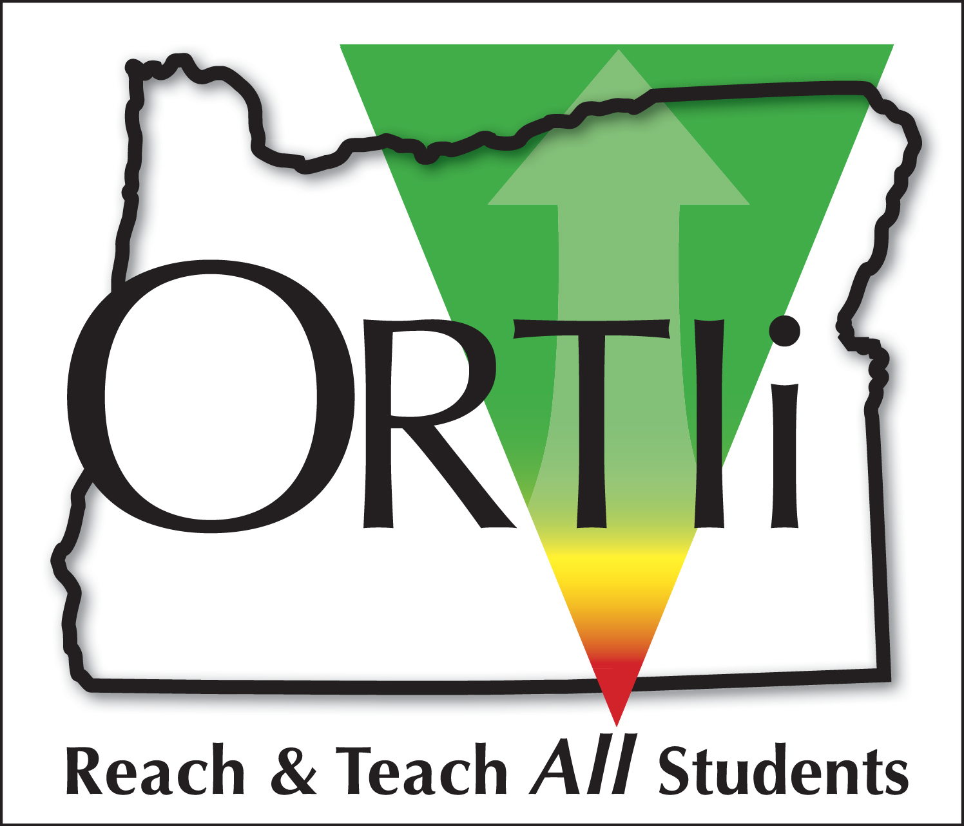

The Oregon Response to Instruction and Intervention (ORTIi)
Elementary Reading Cadre 11 Application, May 2017

SECTION I – INTRODUCTION AND GUIDANCE

What is ORTIi?
Oregon’s Response to Instruction and Intervention (ORTIi) assists districts in developing the capacity to implement and sustain a Response to Intervention (RTI; also referred to in this document as Multi-Tiered Systems of Support, MTSS) framework that support all students. Our goal is to support district implementation efforts that increase overall student achievement, reduce students at-risk for reading failure, and to accurately identify students with Specific Learning Disabilities (SLD). ORTIi has been an ODE initiative since 2005 and has served over 90 districts since that time. Please visit our website at www.oregonrti.org for more information.

What Are the Prerequisites For Participation?
  - Oregon districts that have not previously participated as a “Full Support” district are eligible to apply (i.e., Completed the ODE application process and received funding, ongoing on-site coaching support, etc., see attached list)
  - Have an ODE approved researched-based elementary core reading program OR use an independent adoption that includes materials that meet the criteria established by the State Board of Education. Districts with independent adoptions will complete the ODE ELA Adoption Criteria checklist and the ORTIi Curriculum Review Guide to demonstrate that the adoption meets these criteria. ODE approved core reading programs include:
      - Houghton Mifflin Harcourt: Journeys
      - Benchmark Education Company: Benchmark Literacy Common Core K-6 Whole & Small Group with Resources Oregon Edition
      - McGraw Hill Education: Reading Wonders Grades K-6 & Reading Wonderworks Grades 1-6
      - Pearson Education, Inc.: Scott Foresman Reading Street-Common Core
      - Cengage Learning Inc.: Reach for Reading
  - Have a research-based universal screening system (i.e., DIBELS, easyCBM, AIMSweb). Other screeners may be considered if they possess the following attributes:
    - Address grade appropriate components of the Five Big Ideas of Reading.
    - Are brief and easy to administer so that they can be used 3 times a year with ALL students.
    - Contain comparable, equivalent forms for Progress Monitoring that can be used for brief, repeated assessment on one-week intervals.
    - Are sensitive to growth.
    - Are research-based, and have adequate reliability and validity for screening purposes.

4. Have commitment from the core leadership team (Superintendent, District Office Administrators, and Elementary Principals) to provide leadership, time, professional development, and other resources necessary to support the implementation of a comprehensive framework.

What Are the Benefits to Participating Districts?
RTI, when implemented fully and with integrity, has demonstrated many positive outcomes including increased student reading achievement and more accurate rates of Specific Learning Disability identification. Although many districts have some MTSS elements in place, enhancing the effectiveness and sustainability of these systems takes a strong understanding in systems level change and technical knowledge and skills. ORTIi helps districts expand their capacity for systems development and increase their technical knowledge and skills so that they can implement comprehensive and integrated MTSS frameworks that are effective and sustainable.

ORTIi districts that have implemented effectively have:
- Increased the percentage of students reading proficiently.
- Decreased the achievement gaps that exist between student groups with different racial/ethnic, economic, and language backgrounds.
- Decreased the percentage of students who need the most intensive level of academic support, including students identified with Specific Learning Disabilities.
- Created a more positive, collaborative, and success-oriented school culture.

What Does Participation in ORTIi Provide?
The ORTIi project provides support to participating districts for up to four years. Support is focused on reading at the elementary level around the RTI Essential Components in the graphic below.
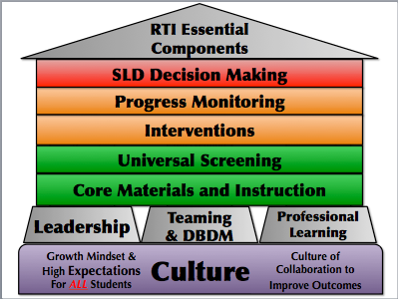
Participating districts receive:
1. A structured scope and sequence of trainings provided through
statewide and regional conferences.
2. A dedicated Implementation Coach that provides on-site and
remote coaching and technical assistance.
- Funding to help offset the costs of professional development
activities such as travel expenses, release time, etc.
4. Data tools to evaluate districts’ implementation progress.
5. Access to implementation, instructional, and assessment tools.

Who Should Apply for the ORTIi Project?
Districts that are committed to improving outcomes through a systematic MTSS approach should consider applying in order to build or further develop the following components:
- Strong core reading and intervention instruction.
- An assessment system that identifies the health of core instruction, students needing intervention support, and students not making sufficient progress with interventions.
- Teaming processes to identify the instructional needs at the district, grade and individual student levels.

What Are the Commitments for Participating Districts?
Districts in the ORTIi project agree to the following:
- Establish and maintain implementation teams:
- A District Implementation Leadership Team (DILT) that includes district administrators, elementary building principal(s), and other district leaders. This team meets at least monthly to build district capacity and consensus to support an MTSS infrastructure.
- A Building Implementation Leadership Team (BILT) for each elementary school consisting of the building principal, select teachers from primary and upper grade levels, and specialists.
- Develop Standards of Practice (district wide agreements) and implement essential MTSS components, including the following:
- Core Reading Program
  - Time: 90 minutes per day (based on 5 day week)
  - Materials and instructional strategies to be used by staff
- Assessment System
  - Universal Screening
  - Progress monitoring
  - Diagnostic
- Interventions
  - Standard Reading Protocol (Evidenced-based interventions to be used at each Tier)
- Meeting Processes
  - District, grade, and individual student level decision making
- Develop an annual action plan to support training and fidelity of MTSS implementation.
- Provide universal screening and implementation fidelity data to ORTIi and ODE in order to assist in addressing district needs and evaluate overall effectiveness. This includes disaggregating screening data by subgroup.
- Provide read-only access to the district’s Universal Screener.
- Complete ORTIi implementation fidelity measures.
- Provide Specific Learning Disability (SLD) referral and identification rates.
- Participate in trainings over the course of the four years in the ORTII project.
- Designate a district based facilitator who will support implementation of MTSS practices within the district (e.g., planning of professional learning, coaching and data support)
- Implement all components of an MTSS system including the capacity to use RTI for making Specific Learning Disability (SLD) eligibility decisions. Districts are encouraged, but not required, to use an RTI approach to determine SLD eligibility.

What is the Application Process?
- Who completes the application?
The application must be completed by a team that includes the superintendent, district office administrators, principals, and other key staff in leadership positions. It is critical that the application be completed with direct input from district leaders that are positioned to allocate resources and make decisions regarding district goals, procedures, and instructional practices.

- What are the components of the application?
The application is divided into four sections, and each is in a separate document.
    - Read and understand Section I: Introduction and Guidance (this document).
    - Complete Section II: ORTIi District Implementation and Evaluation Tool-District Based v2 (DIET-DB2). Reference the DIET-DB2 Guidance Document as you complete this assessment.
    - Complete Section III: Implementation Resources and Planning Questionnaire.
- Complete Section IV: Signature Page. This document must be signed by the Superintendent, the Director of Curriculum (or equivalent), the Director of Special Education (or equivalent), and all elementary principals. Signatures indicate that the signee has read the introduction and the completed application sections, and agrees with the information that the district has provided.
- Send completed materials electronically to: Lisa Darnold, Director, Regional Programs and Best Practices, Oregon Department of Education (lisa.darnold@state.or.us).
- Timeline:
Applications will be accepted until 11:59 PM, Monday, June 28, 2017.
- Selection:
All districts that meet the requirements listed above and have full commitment from district leadership will be considered for participation. Final selection decisions will be made collaboratively by ORTIi and ODE based on district readiness and commitment.

NAME (TYPED OR PRINTED) SIGNATURE DATE

_______________________________ _______________________________ ______
Superintendent

_______________________________ _______________________________ ______
Director of Special Education (or equivalent)

_______________________________ _______________________________ ______
Director of Curriculum & Instruction (or equivalent)

_______________________________ _______________________________ ______
Other Pertinent District Administrator

