IPAS

Intervention Planning and Assessment System

User's Guide

Contents
Using IPAS to Facilitate the RTI Process 5
Entering Screening Scores 6
Entering Screening Score Directly in to IPAS 6
Screening Score Upload 7
Converting from an external data source 7
Screening Score Upload 8
Reviewing Student Performance and Identify Student Needs 9
Assigning Students to Progress Monitoring and/or Intervention 10
Monitoring Students Below Grade Level 12
Adjusting Student Targets 13
Entering Progress Monitoring Scores 14
Reviewing Student Progress 15
Changing Interventions 16
Changing Interventions for a single student 16
Changing Interventions for a Group of Students 17
Exiting a Student from Interventions 18
Test Administration Tools 19
MAZE and DAZE Delivery and Scoring Tool 19
DAZE Instructions Modified for Tablets 20
Reports 22
Summary of Effectiveness Report 23
Summary Report 24
Cohort Report 25
Class List Report 27
Class List Report 27
Intervention Change Recommended Report 28
Curriculum Report 28
Interventions Report 29
Student History Report 30
Demographic Report 31
Grade Level Report 32
School Report 33
Initial Configuration 34
Copying from a Default Configuration 35
Manual Configuration 37
Set the School Year 37
Define the Subject Areas or Domains to use with IPAS 38
Define Tests and Goals 40
Additional Settings for Creating Tests 42
Defining Curriculum, Interventions, and Protocols 43
Defining Assessment Windows or Periods 44
Setting Decisions Rules for Changing Interventions 45
Adding Students to the System 46
Adding Students Through a Test Record Upload 47
Adding Students through a Student Record Upload 47
Manually Adding Students to the School Roster 48
Create User Accounts for Staff 50
Rolling Over Configurations for a New School Year 51
Configure the School Year 52
Copy Available Tests from the Prior Year 53
Add Students to the New School Year 53
Test Administration Tools Setup 54
MAZE and DAZE Setup 54
Create Passages 54
Format of Text 55
Create Test Sessions 55
Resetting Student Access 57
IPAD DAZE Delivery Comparability Study 58
DIBELS Next Composite Benchmark Calculations 62

Using IPAS to Facilitate the RTI Process

Data-based decision making is a vital part of a healthy Response to Intervention System. Data is used to create curricular and instructional improvements, design interventions, and decide which students will benefit from additional tiered instruction. The following data-based decision making processes are essential in ensuring all students are successful:

- 100% Meetings (Tier 1): Three times a year, following universal screening, grade level teams, along with administrators and support staff, analyze these data to determine the health of core instruction and to identify which students may need interventions. At these meetings the team also determines the essential priority skills for the grade level and agree on strategies for addressing these skill needs. IPAS contains many reports that help guide this process including the Summary Report, Summary of Effectiveness Report, and the Demographics Report.

- Intervention Placement Meetings (Tier 2/3): Following the 100% Meetings, a team meets to determine which students need intervention supports. The team uses universal screening data, core program assessments and other data along with decision rules to guide selection of these students. It’s imperative that the team uses a process to place these students in appropriate interventions, matched to their skill and instructional needs. These teams are also available to meet as needed. The Screening Page in IPAS helps teams identify the lowest performing students, as well as identify what specific screening sub-skills they need the most support on.

- Group Intervention Review or 20% Meetings (Tier 2/3): Grade level teams along with administrator and support staff meet every 6 to 8 weeks to review progress of groups of students in interventions and determine next steps. IPAS reports that can help guide this process include the Cohort Report, Intervention Change Recommended Report, as well as viewing individual student graphs on the Progress Monitoring Page.

- Individual Problem Solving Meetings (Tier 3): After a student has not made adequate progress in several group interventions, an individual problem-solving meeting is held to analyze data and select an individually designed intervention for that student. IPAS reports that can help guide this process include the Cohort Report and Student History Report, as well as viewing the individual student progress monitoring graphs on the Progress Monitoring Page.

Entering Screening Scores
At least three times a year all students should take a screening test. Most often these tests will occur in the fall, winter and spring. There are two ways to enter these scores in to the IPAS system. The recommended, and most direct, method is to enter the scores directly in to IPAS. If a secondary system has been used for data entry such as DIBELS, EasyCBM or AIMSweb, data can be exported from those systems and manipulated to be imported in to IPAS.

Entering Screening Score Directly in to IPAS
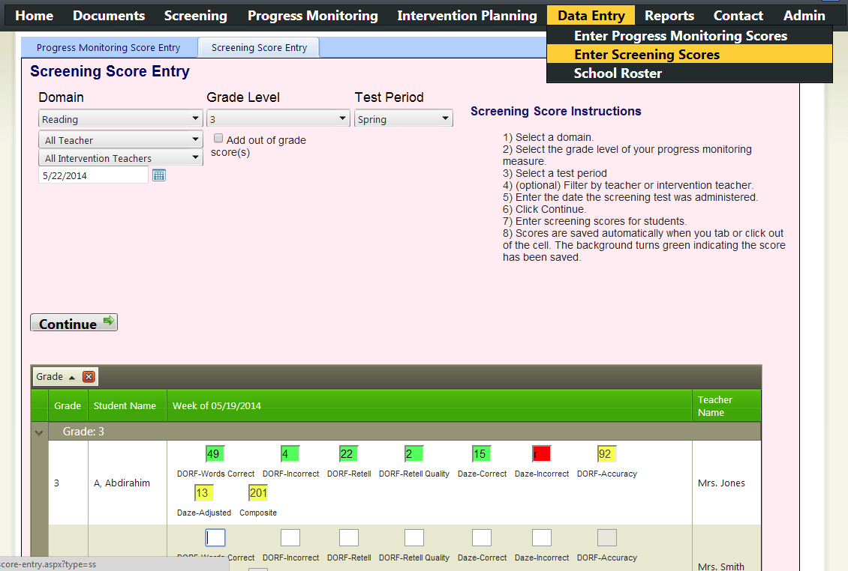
1) Access this pink Screening Score Entry Tab under Data Entry.
5) Enter scores, pressing tab to move between boxes.
- A green box indicates the score has been recorded.
- A red box is not a valid score.
- A yellow box is a score which was calculated and recorded.
4) Click Continue to load the student list.
3) Choose Date the screening test was given.
2) Choose the Domain, Grade Level of the test and Test Period or Window.

Screening Score Upload

Converting from an external data source
IPAS includes a converter that converts screening data from several other popular data systems.
Specifically:
- University of Oregon's DIBELS Data System
- DIBELS.net
- easyCBM
1) Access this Converter from the Admin Menu
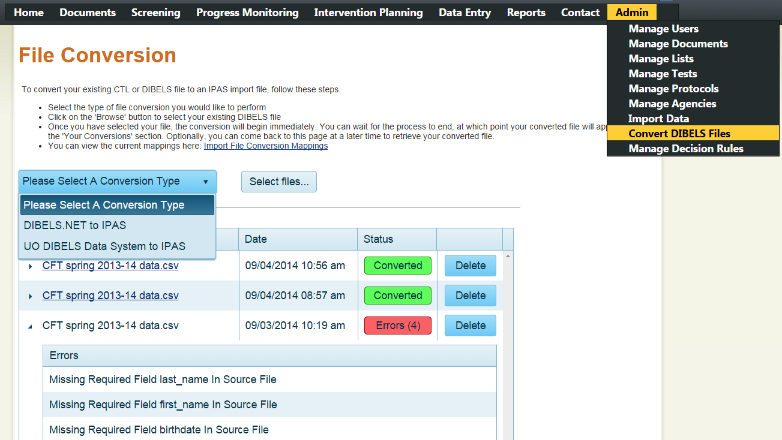
5) If there are errors, click the triangle next to the file name to view them
5) When the Status reads Converted, click the file name to download a file that is ready for import.
4) The status process will indicate processing. You can leave this page and return later to check the progress.
3) Upload your file
2) Choose the data system you're converting from.

Screening Score Upload
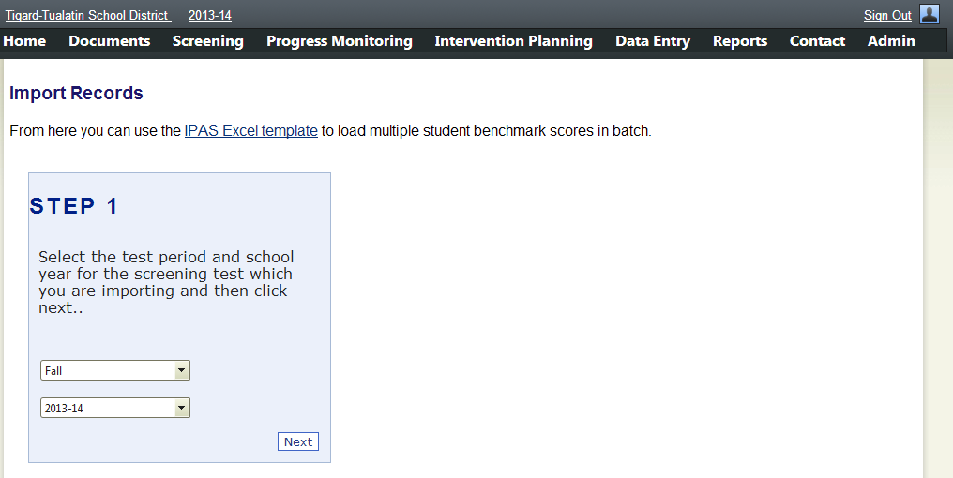
3) Choose the appropriate test window and year. Then click Next.
Optional information can be included such as birthdate, gender, OAKS scores, Attendance, etc...
2) Download the IPAS Excel template by clicking here.
1) Access this Import Data screen from the Admin Screen.
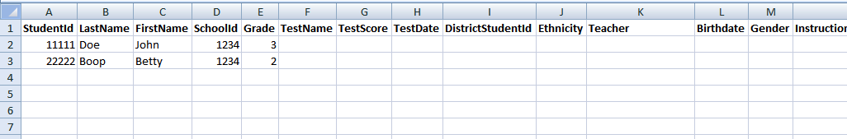
Note: If uploading Ethnicity, the text must match exactly the text under Manage Lists.
5)Include the three Test fields. The Test Name must match a test under Mange Tests
4) Minimum required fields to upload student roster data.

Tips:
- Data in fields must be visible. Click the triangle to the left of column A to highlight the entire worksheet, then double click between columns A and B to resize the every column at once to the appropriate size.
- Date columns must be in the Date format. Click the column header and change the formatting from General to Short Date.
- Large files will partially process and then generate an error. To avoid this problem, split large files in to multiple files of about 1000 lines each.

Reviewing Student Performance and Identify Student Needs
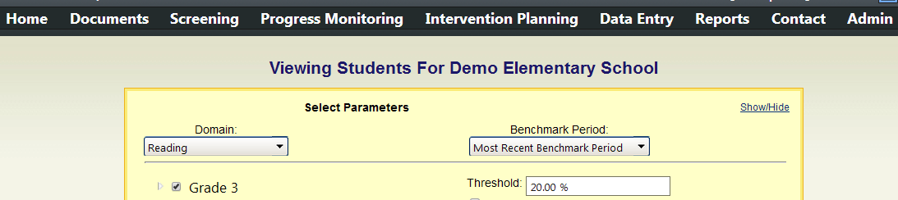
1) Access the Screening page.
4) Click Refresh List to load the student list and scores.
3) Check the grade to review.
2) Choose the domain to review.
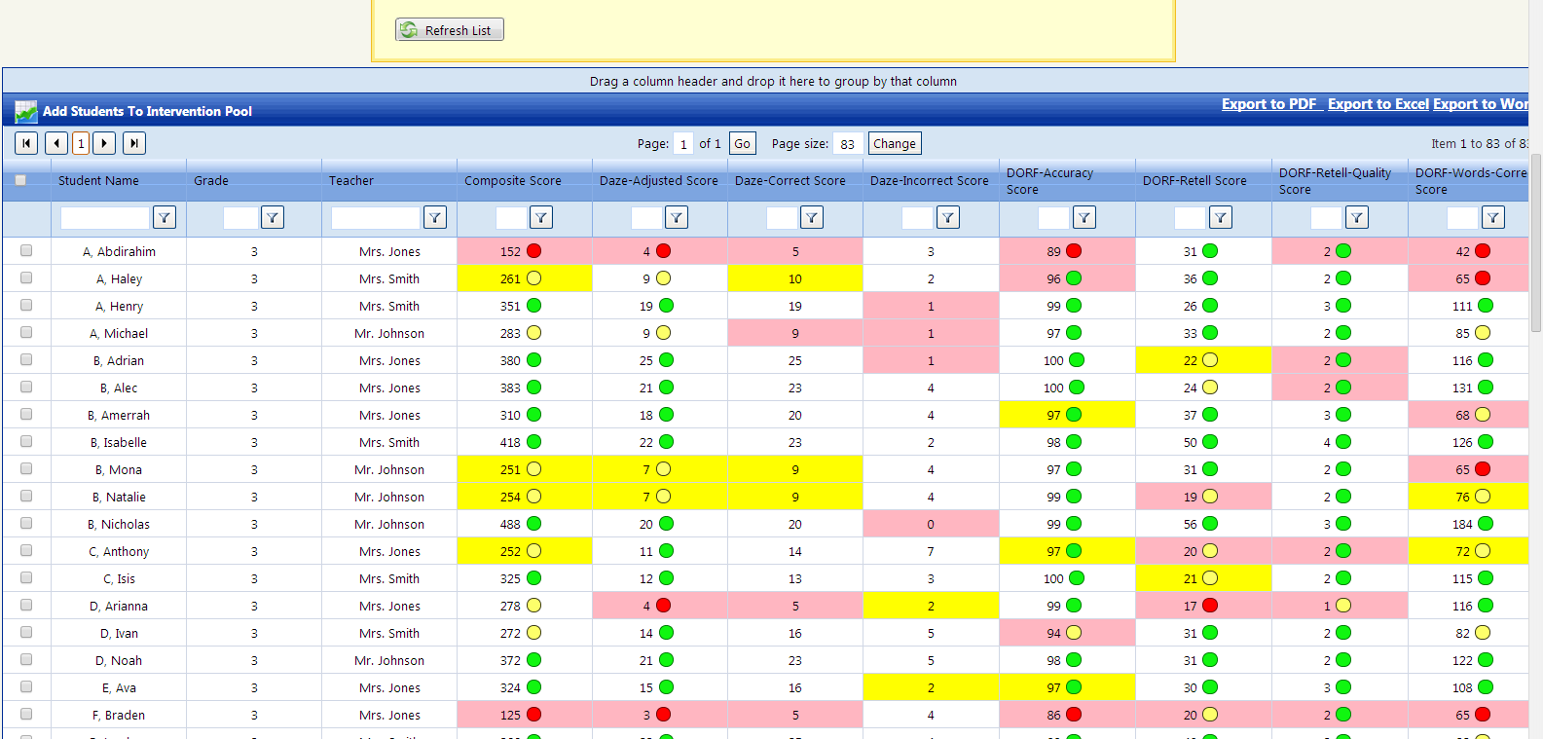
6) The circles indicate the student's risk level in relation to the benchmarks defined under Manage Tests.
7) The pink shading indicates the lowest 20% of this group of students per the threshold setting above.
Yellow shading indicates the 10% above the pink. In this case the 20-30th percentile.
5) Click on any header measure to sort low to high, click again to sort high to low.

Assigning Students to Progress Monitoring and/or Intervention
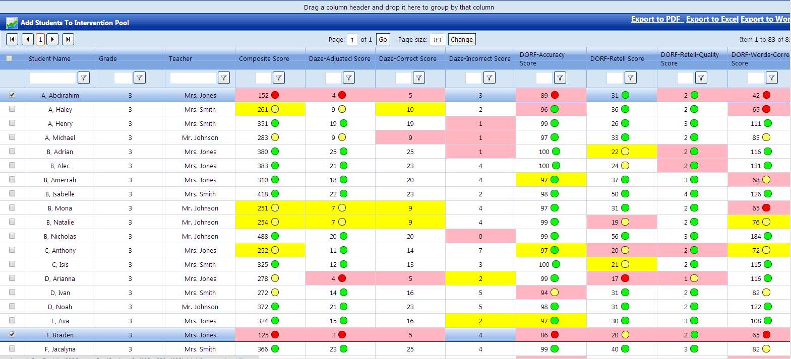
2) Click Add Students to Intervention Pool to begin placing students in to intervention.
3) This window indicates that students have been identified for intervention. Click Next to add these students progress monitoring.
1) On the Screening page, use the check boxes to select one or more students for intervention.
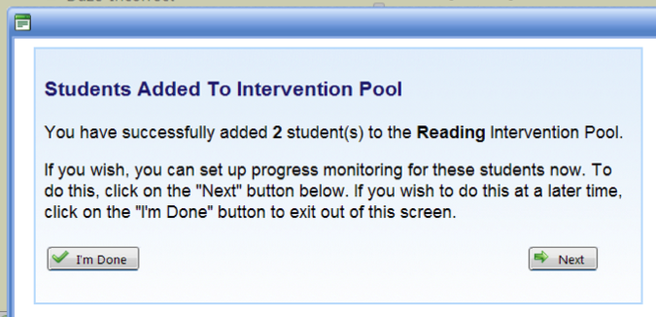
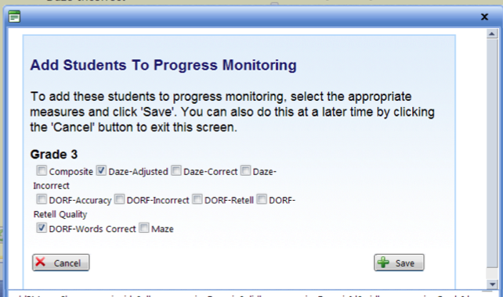
5) This window indicates that students have been added to progress monitoring. Click Next to add the students to an intervention.
4) Check all the measures on which these students will be monitored. Then click Save.
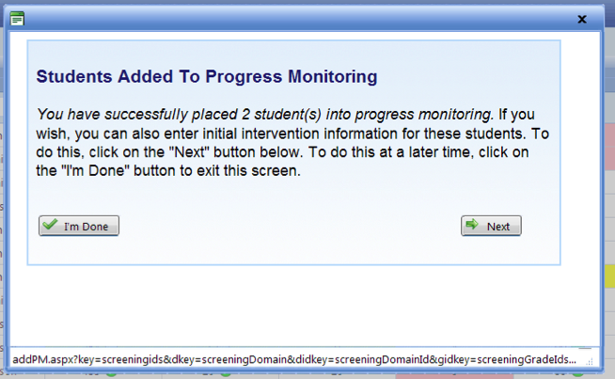
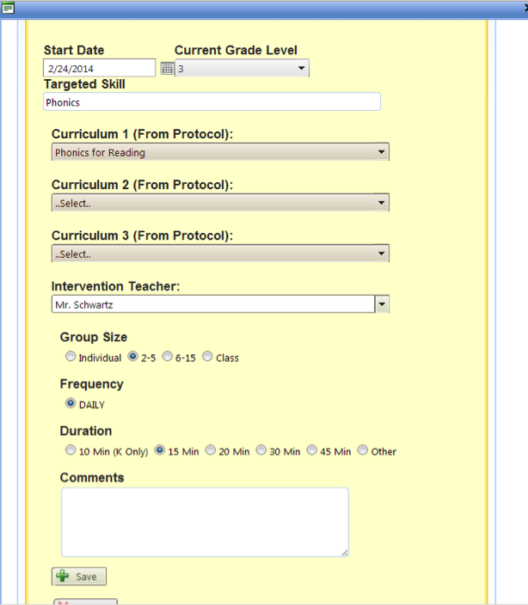
7) This screen indicates that students have been assigned to intervention.
Click Close.
6) In this window the details of the Intervention can be specified and applied to all the checked students.
Up to three curriculums from the Manage Protocol screen can be specified for the intervention.
The Intervention teacher can be specified and used to later filter results and reports. If the teacher doesn't exist in the list, simply type the name in to the box.
Comments applied here should be specific to the intervention and are applied to all students in that intervention.
Click Save.
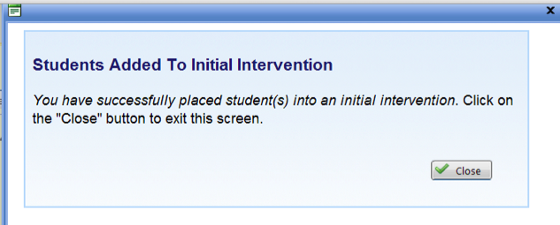

Monitoring Students Below Grade Level
It is possible to progress monitor students with below grade level measures. In order to do this you must first enter a screening score for that grade level. Follow the directions for Entering Screening Scores Directly in to IPAS, but then check the "Add out of grade score(s)" box to enter a score below grade level.
After adding the lower grade level score, the student will appear on the screening page for the lower grade level. Check the box next to the student's name and follow the directions for Assigning Students to Progress Monitoring and/or Intervention to begin progress monitoring below grade level.
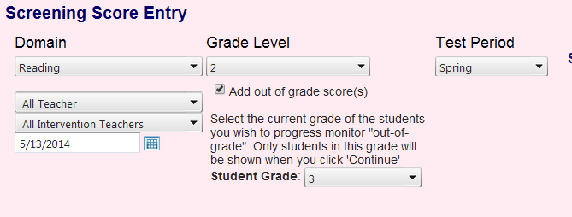
3) Choose the grade level of the student.
2) Check the box to enter "Out of Grade" scores.
1) Chose the grade level of the test
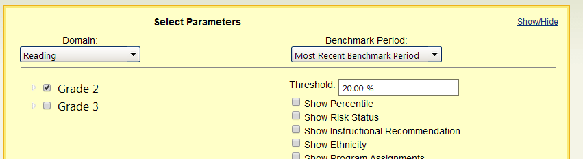
4) The student will then appear in the lower grade level on the Screening page and can be added to progress monitoring from there by following the directions for Assigning Students to Progress Monitoring and/or Intervention.
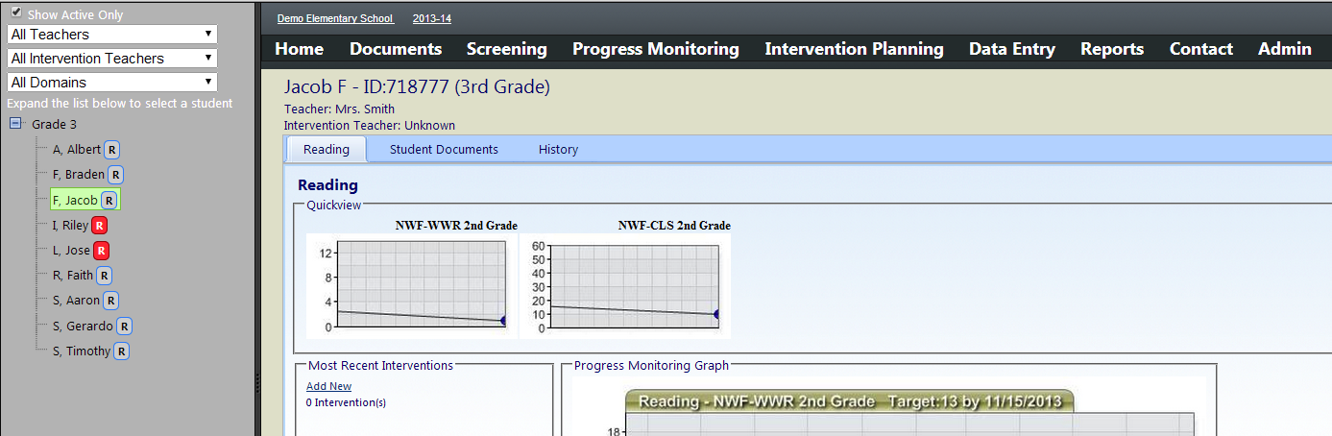
This student is in the 3rd grade, but is now being progress monitored on 2nd grade measures as indicated in the headers of the graphs.
This student is in the 3rd grade, but being progress monitored on 2nd grade measures as indicated in the headers of the graphs.
This student is in the 3rd grade, but being progress monitored on 2nd grade measures as indicated in the headers of the graphs.

Adjusting Student Targets
The default target for every student in IPAS is the benchmark goal defined on the Manage Tests screen. Each time a student is added to progress monitoring, the system will automatically add an aimline to the benchmark goal. Some students may have alternative targets more appropriate to their learning level or intervention plan.
For example: The goal for 1nd grade oral reading fluency is to reach 47 words by the end of the year. However, a goal for a 2nd grader being monitored using 1st grade materials might be to reach the first grade goal by January. Similarly, a student may have a goal of reaching a point lower than the default benchmark by the end of the year.
IPAS facilitates these adjustments to students' goals by changing the options on the progress monitoring graphs.
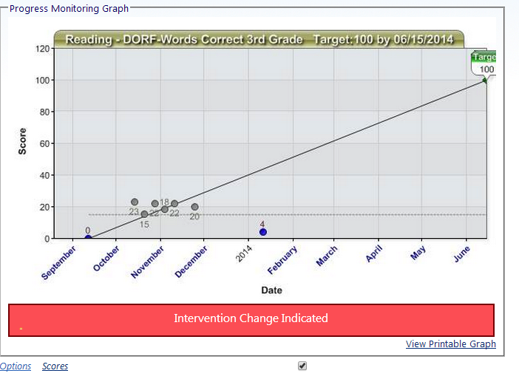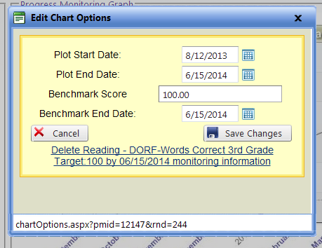
2) Click Save Changes
The Plot dates adjust the start and end of the graph.
1) Adjust the Benchmark score and end date to customize this student's targets.
To set an alternative target for this student, click Options below the Progress Monitoring graph.

Entering Progress Monitoring Scores
The key to an RTI system is continuous monitoring of student progress toward their goals. The Progress Monitoring Score Entry page allows for the quickly entry of up to 4 weekly tests for each student at one time. These data points will appear as progress monitoring points on the students' graphs and create the students' trendlines.
1) Access this yellow Progress Monitoring Score Entry Tab under Data Entry.

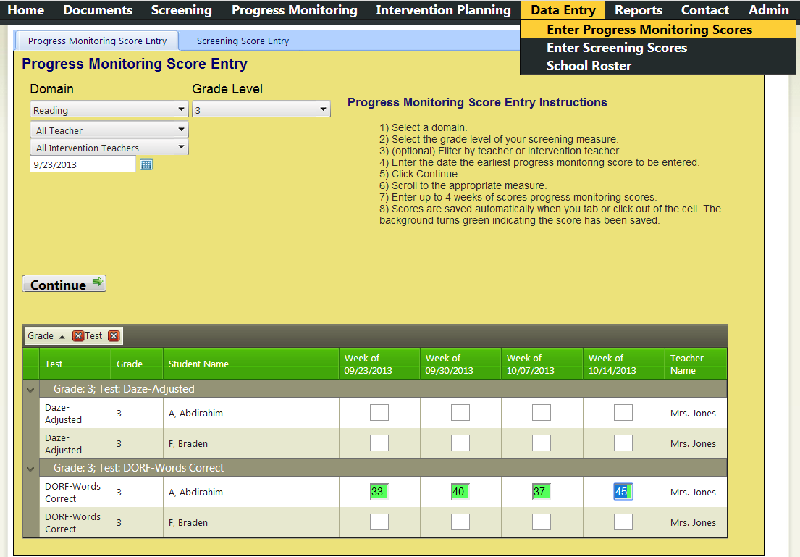
3) Enter scores, pressing tab to move between boxes.
- A green box indicates the score has been recorded.
- A red box is not a valid score.
Up to 4 weeks of data can be entered on this screen.
Entry boxes are grouped by test.
2) Select the Domain and Grade Level and the Date of the earliest set of scores to be entered.
Click Continue to load the entry screen.

Reviewing Student Progress
The IPAS system is designed to facilitate RTI and a primary focus of the system is the review of progress monitoring data on individual students. The Progress Monitoring page allows teams of educators ready access to data on all students who are progress monitored and/or receiving interventions.
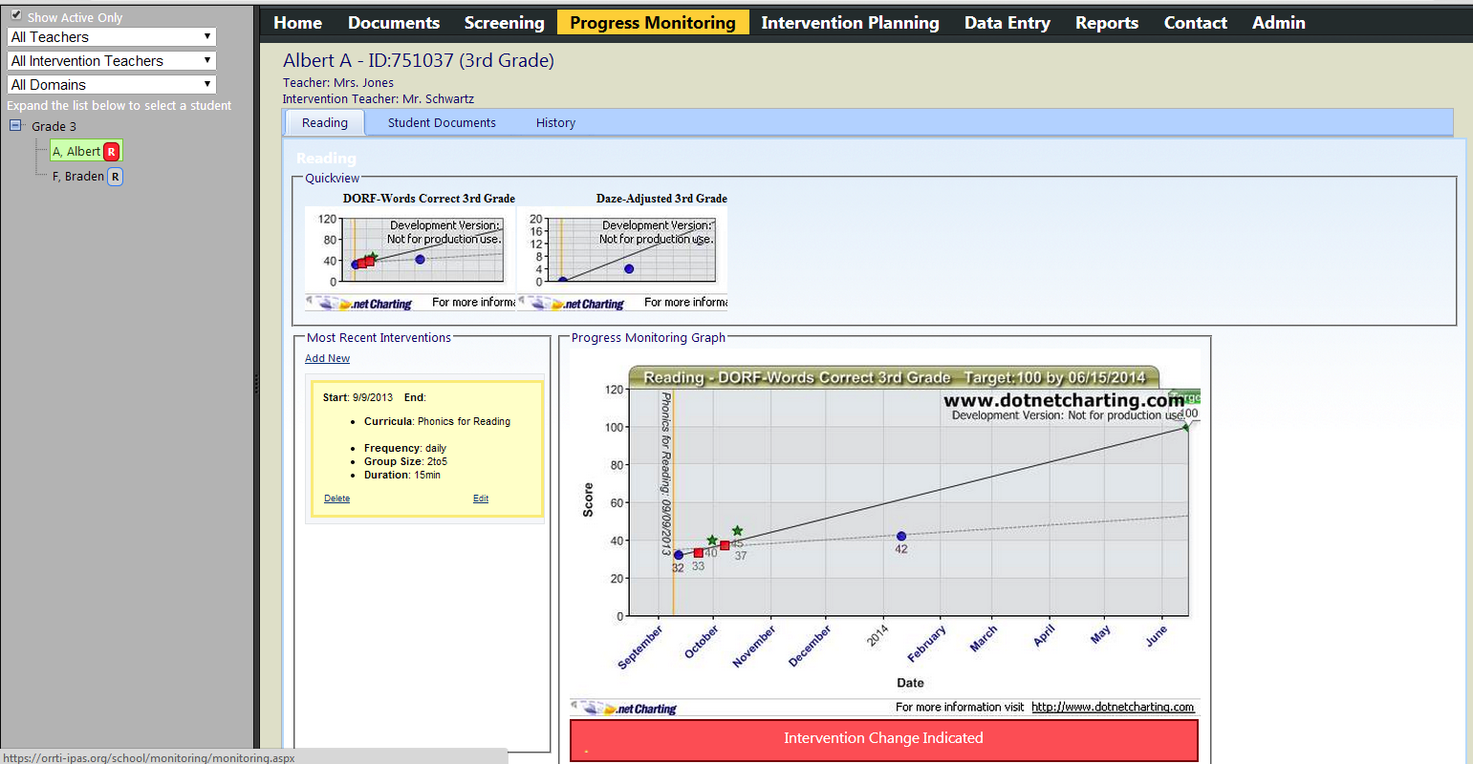
If the decision rules set on the Manage Decision Rules page indicate a review, this flag will appear.
The two most recent interventions are detailed here.
4) Select the specific measure to review.
3) Select the Domain to review from the tabs.
2) Expand the Grade Level and select a student from the list to review the student's data.
Letters after the student's name indicate the domains in which the student is being monitored. The indicators turn red when an intervention change is indicated.
1) Access the Progress Monitoring page.
The phases of intervention are clearly indicated by vertical lines on the graph.
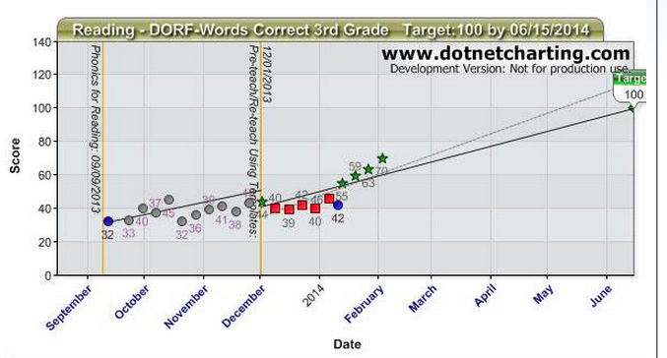
The student's Trendline appears as a dotted line.
Screening Scores appear as blue dots.
The Aimline appear as solid lines and originate at either the screening score before the intervention, or the first three progress monitoring points.

Changing Interventions
After a period of review, it may be determined that a students' intervention isn't having the desired outcome. In those cases it may be necessary to change the student's intervention. There are two primary methods for accomplishing this.

Changing Interventions for a single student
Most often, adjustments to intervention will happen for a single student at a time. These adjustments can be made by adding a new intervention next to the progress monitoring graph.
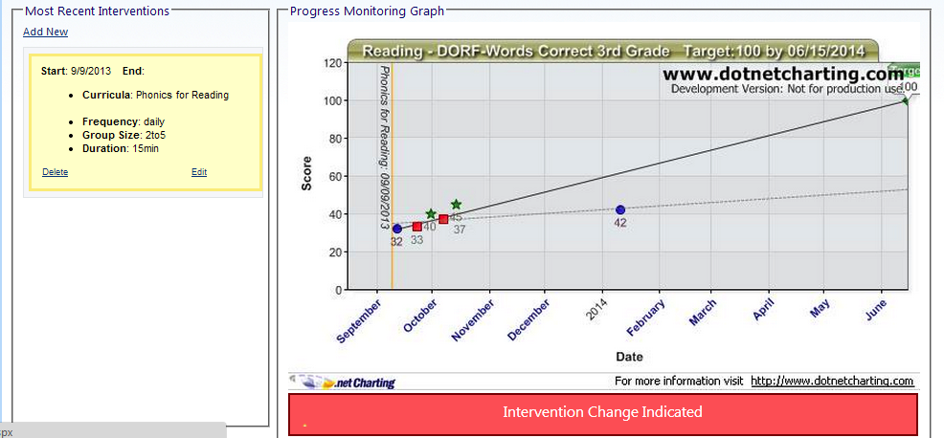
2) In this window the specifics of the Intervention can be specified.
Up to three curriculums from the Manage Protocol screen can be specified for the intervention.
The Intervention teacher can be specified and used to later filter results and reports. If the teacher doesn't exist in the list, simply type the name in to the box.
Comments applied here can be specific to the student and are applied only to this student.
Click Save.
1) Click Add New on the list of most recent interventions.
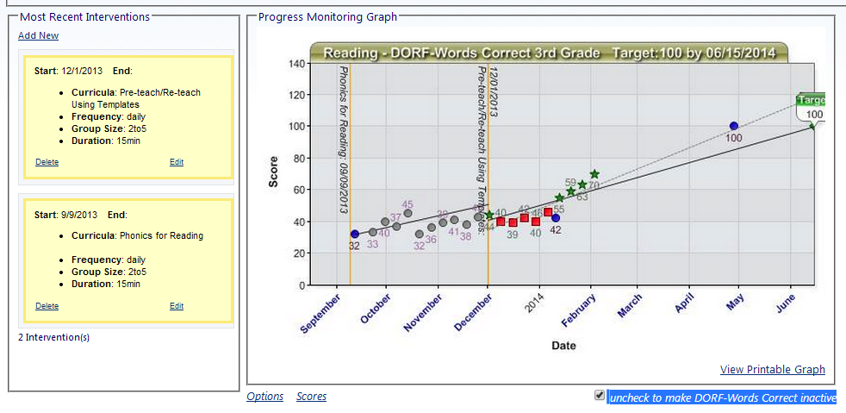
A line is added to the graph indicating the change in intervention and a new aimline and trendline are drawn for the new intervention.
The new intervention is added and the old intervention is moved down the intervention list.

Changing Interventions for a Group of Students
It may be necessary to change the intervention for a large number of students at a time. For example, when creating a new intervention group or changing the size of existing interventions. This can be accomplished by returning to the Screening Page and following the directions for Assigning Students to Progress Monitoring and/or Intervention.

Exiting a Student from Interventions
Students who are making great progress through an intervention may no longer need the intervention and/or progress monitoring. To exit a student from progress monitoring, uncheck the box below the graph. If it's later determined that a student needs additional progress monitoring, the box can be re-checked to resume progress monitoring.
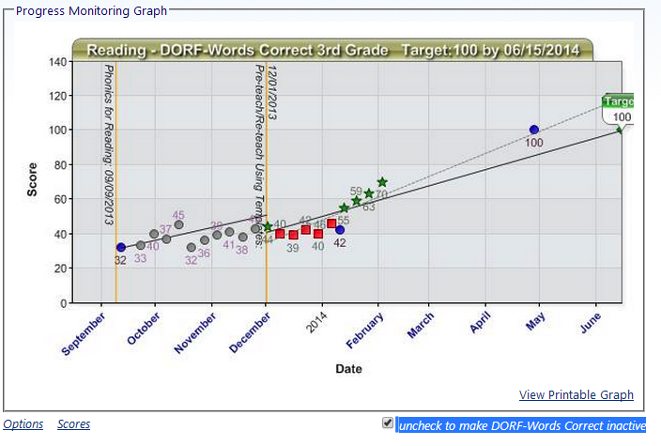
1) Uncheck the box to remove this student from progress monitoring.

Test Administration Tools
To streamline the process of test delivery and scoring, IPAS has the following Test Administration Tools:
- MAZE and DAZE task delivery and automated scoring

MAZE and DAZE Delivery and Scoring Tool
The MAZE and DAZE Delivery tool is designed to be used with students on IPADs or other touch screen devices. The use of this tool with mice or laptop touchpads has not been studied to ensure that it produces valid scores which can be used with national norms.
The MAZE and DAZE tests are delivered to students in a whole group setting. Each student needs an IPAD and 3 pieces of inforation to login:
- Student ID as recorded in IPAS
- First Name as recorded in IPAS
- the Session Code for the test they will be taking. The Session Code is set by the IPAS administrator. (See the section on MAZE and DAZE Setup – Create Test Sessions.)
To begin testing, Students go to the following web address on any web browser:
https://orrti-ipas.org/maze/
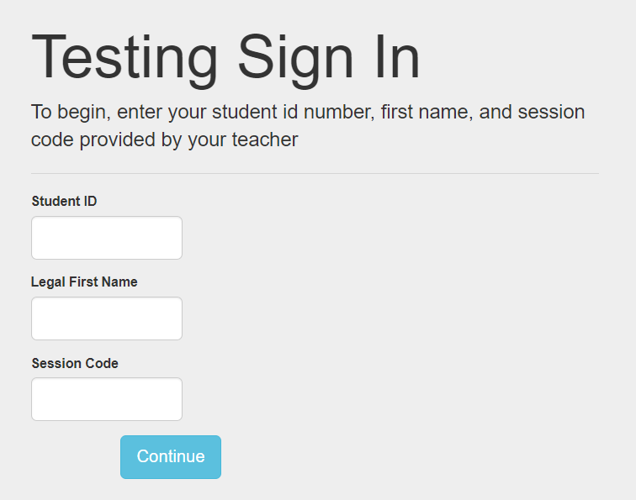
After logging in, a student is presented with the two practice items created by the administrator. Per the DAZE administration, these practice questions are to be led by the test facilitator.
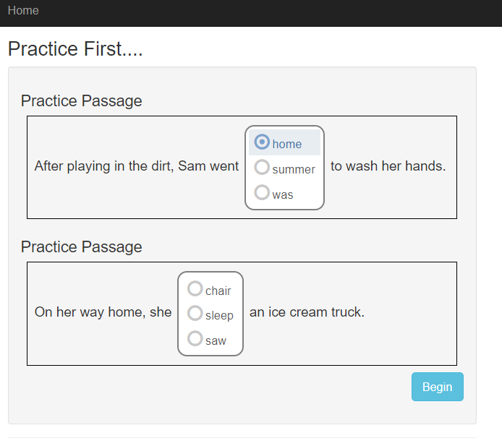
2) Tap Begin to start the MAZE or DAZE test.
1) Tap to select an answer. Tap a different word to change the answer.

1) At the end of the time designated during the Create Passages section (typically 3 minutes), this message appears. Click Continue to return to the login screen.

DAZE Instructions Modified for Tablets
Dynamic Measurement Group (DMG) provides directions for DAZE tests. Below is an example of how those might be modified to deliver online tests using this tool:
We’re going to do these practice questions together before we start the story. Please wait for my instruction before pressing begin.
You are going to read a story with some missing words. For each missing word there will be a box with three words. Tap the word that makes the most sense in the story. Look at Practice 1.
Listen. After playing in the dirt, Sam went (pause) home, summer, was (pause) to wash her hands. You should tap the word “home” because “home” makes the most sense in the story. Listen. After playing in the dirt, Sam went home to wash her hands.
Now it’s your turn. Read Practice 2 silently. When you come to a box, read all the words in the box and tap the word that makes the most sense in the story. When you are done look to me before continuing. (allow up to 30 seconds for students to complete the example. If necessary, after 30 seconds say Eyes on me.)
Listen. "On her way home, she (pause) chair, sleep, saw (pause) an ice cream truck." You should have tapped "saw" because "saw" makes the most sense in the story. Listen. On her way home, she (pause) saw (pause) an ice cream truck. If you tapped “chair”, you can change your response by tapping “saw”.
When I say "begin", tap the begin button and start reading the story silently. When you come to a box, read all the words in the box and tap the word that makes the most sense in the story. Ready? Begin.
At the end of 3 minutes, the website will tell students their test is complete.

Reports
IPAS includes a number of reports for evaluating the effectiveness of individual interventions as well as the educational program as a whole.
 | Report | Description
Group | Summary of Effectiveness | Effectiveness of Core and Intervention Programs
Group | Summary Report | Benchmark Performance of Core and Intervention Programs
Group/Individual | Cohort Report | Progress of a Cohort of Students and Individual Students within the Cohort
List | Class List Report | Benchmark Performance of Students in Core and Intervention classes
List | Intervention Change Recommended Report | List of Students who may not be making adequate progress in their current intervention.
List | Curriculum Report | List of students assigned to each intervention curriculum
Individual | Interventions Report | Current Intervention for a student
Individual | Intervention History Report | Cross Year Intervention and Progress Monitoring History for a student
Individual | Student History Report | Cross Year Benchmark History for a student
Group | Demographic Report | Benchmark Performance of Demographic groups
Group | Grade Report | Benchmark Performance by grade level
Group | School Report | Benchmark performance by school

Summary of Effectiveness Report
The Summary of Effectiveness report details the number of students who are reaching the Benchmarks and Risk Indicators defined on the Manage Tests page. It also summarizes the movement of students between levels of risk.
This report can answer a number of questions:
- Are 80% of our students reaching the benchmarks?
- Is our overall program effective at helping students reach and continue to reach the benchmark?
- Are our interventions helping students reach benchmark?
- Is our core program effective at keeping students at benchmark?
Access the Summary of Effectiveness Report under the Reports menu.
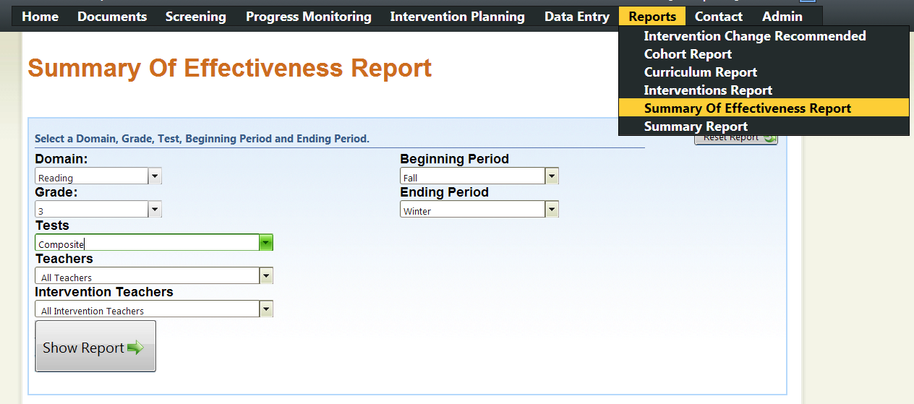
3) Click Show Report.
2) Choose the test windows to compare.
1) Select the Domain, Grade and Test to evaluate.
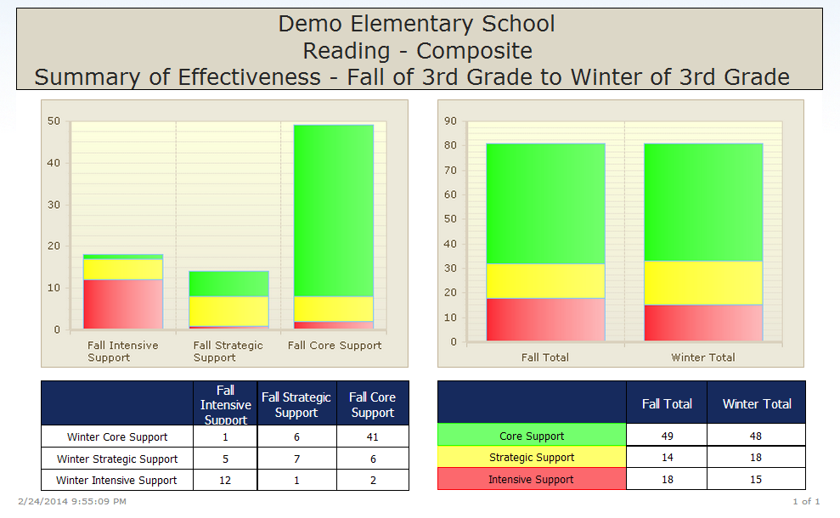
Compare the number of students who needed support in the Fall to the Winter.
Compare he number of students who needed support in the Fall to the Winter.
These students were below benchmark in the fall. The six students in green are now at benchmark in the winter.

Summary Report
The Summary Report details the number of students who are reaching the Benchmark and Risk Indicators defined on the Mange Test page.
This report can answer a number of questions:
- Are 80% of our students reaching the benchmarks?
- Are there specific skills our students need assistance with more than other?
- Is our program effective at helping students reach benchmark on each measured skill?
- Are there skills where our program is not keeping pace with the benchmarks?
Access the Summary Report under the Reports menu.
2) Click Show Report.
1) Select the Domain, Grade and Tests to evaluate.
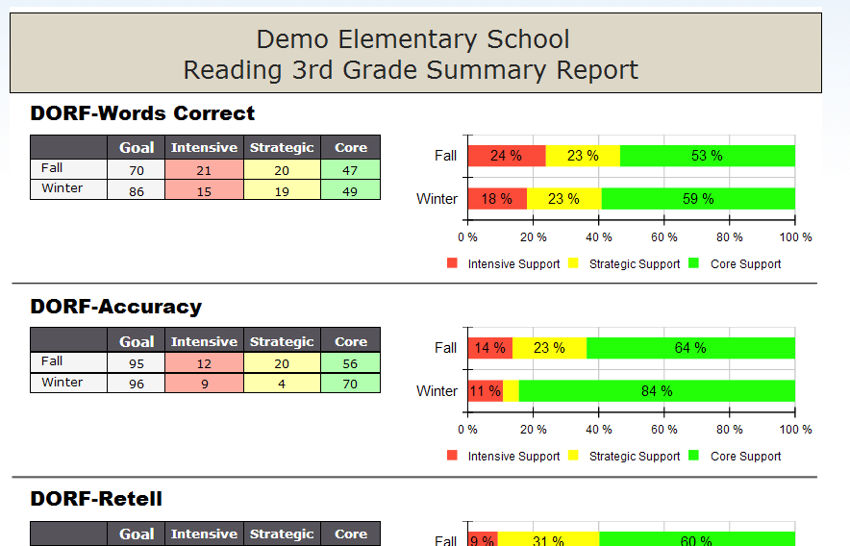
Compare the progress of students in the Fall, Winter and Spring (not pictured).
Compare the progress of students in the Fall, Winter and Spring (not pictured).
Every selected test with defined benchmarks is included in the report.
Every selected test with defined benchmarks is included in the report.

Cohort Report
The cohort report details the progress of a cohort of students overtime. It also allows the progress of one or more students to be compared to the cohorts progress.
This can answer the following questions:
- Is our intervention helping students grow their skills?
- Will our intervention help the students reach benchmark?
- Is our intervention effective for this student as it is for his peers?
- Do we need to do something more or different for this student?
Access the Cohort Report under the Reports menu.
2) Use the double arrow to move all students to the cohort or the single arrow for one student.
1) Choose the test to review.
3) The report will show this cohort. Highlight a student and use the arrows to get individual results.
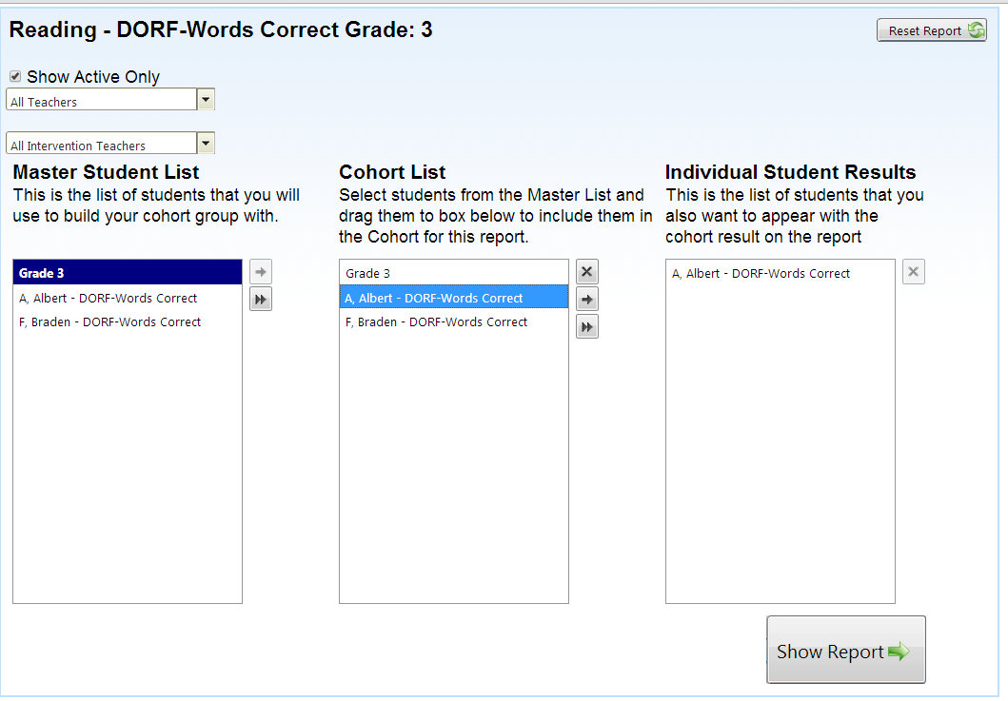
5) Click Show Report.
4) Students in this box will each have their own line on the report. This box can be left blank.

These boxes can be used to show or hide information on the graph.

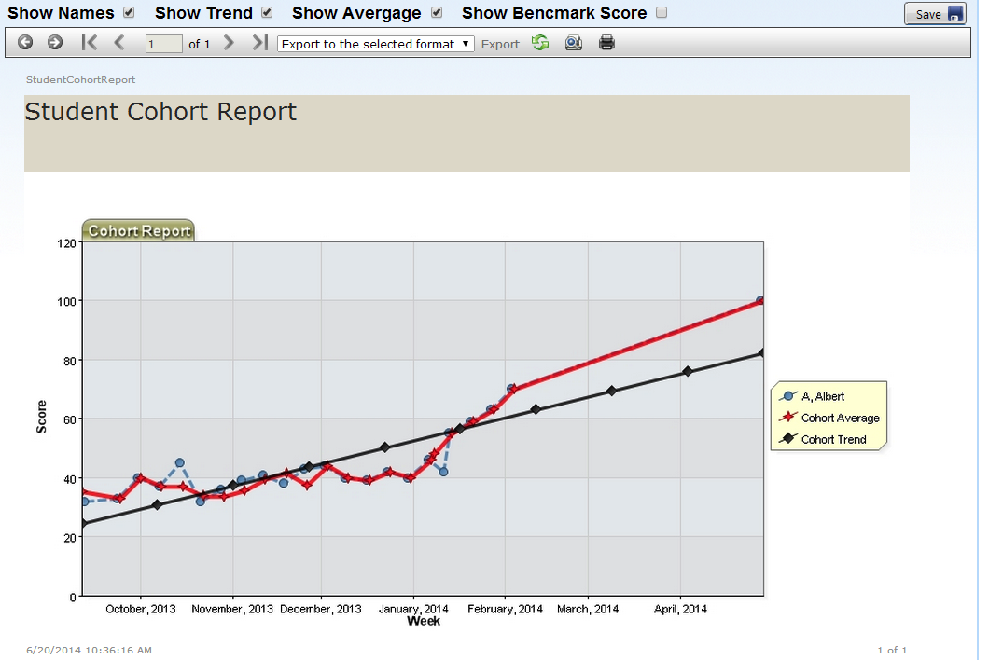
The average scores for the cohort are shown in red and our specific student is shown in blue. We can see he's keeping pace with his peers.

Class List Report

Class List Report
The Class List Report prints a series of rosters with the associated scores for use in the classroom.
This can answer the following questions:
- Are 80% of our students reaching the benchmarks?
- Are there specific skills our students need assistance with more than other?
- Should there be explicit focus on a set of skills in classroom.

1) Access the Class List Report under Reports
2) Choose the Domain, Grade, and Benchmark
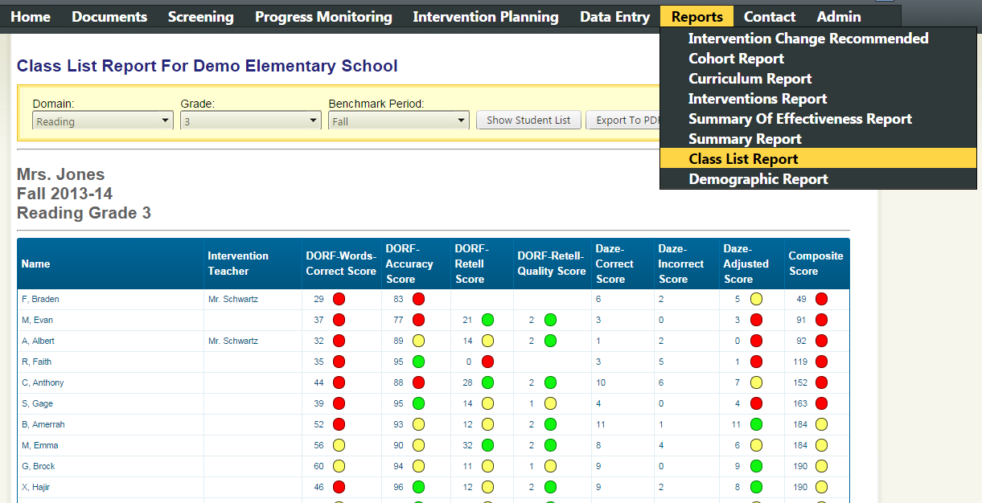
Click Export to PDF to generate printable pages.
Students are sorted by their Composite Score.
A class list is printed for each teacher in that grade.
3) Click Show Student List to preview.

Intervention Change Recommended Report
The Intervention Change Recommended Report lists all students for whom the Decision Rules set under Manage Decision Rules indicate a change.

Curriculum Report
The curriculum report is simply a list of all students being monitored and the interventions they're receiving. This information can be used to determine how many students are being monitored with each measure and which curriculums are being used with students.
This information can also be sorted, filtered and exported to Excel for further manipulation.

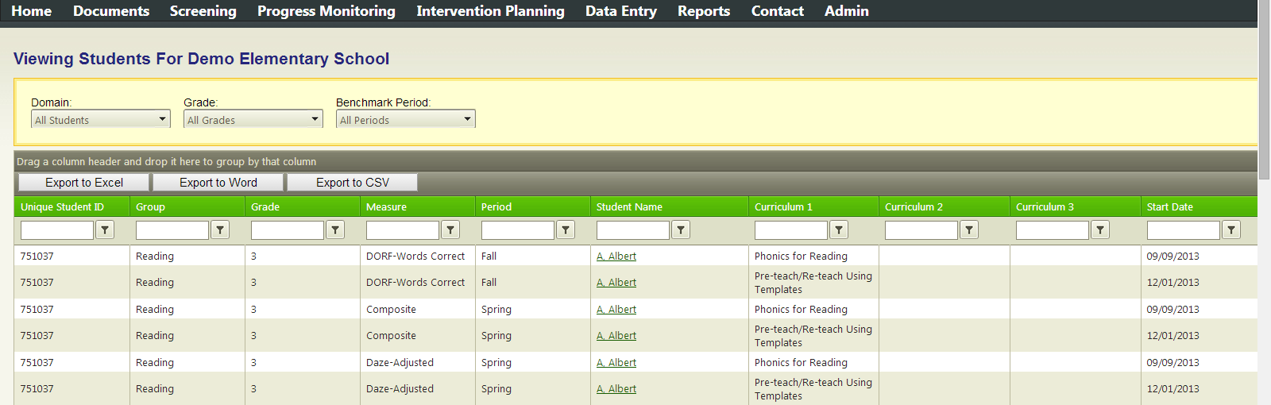

Interventions Report
The Interventions Report prints detailed information about the students' intervention and score history in a single measurement including screening and progress monitoring scores. These sheets can be used for team meetings, conferences or included in the student's cumulative file.
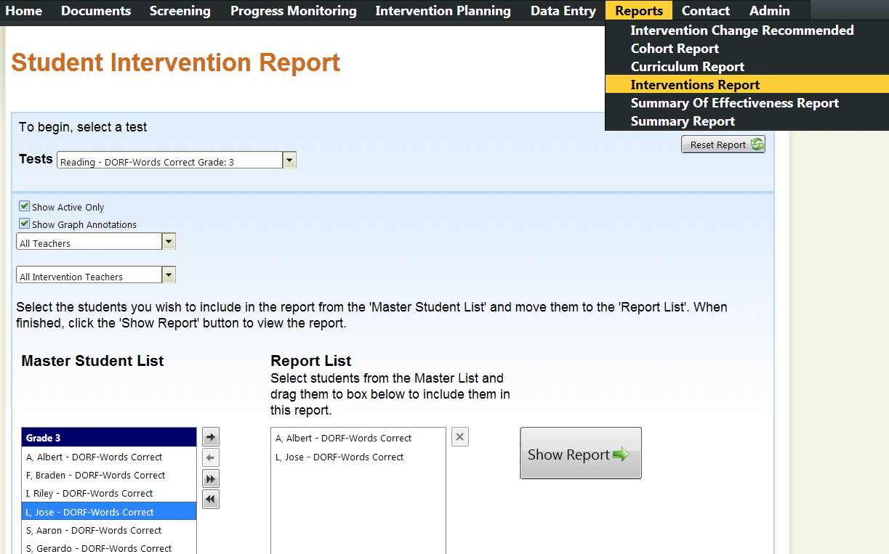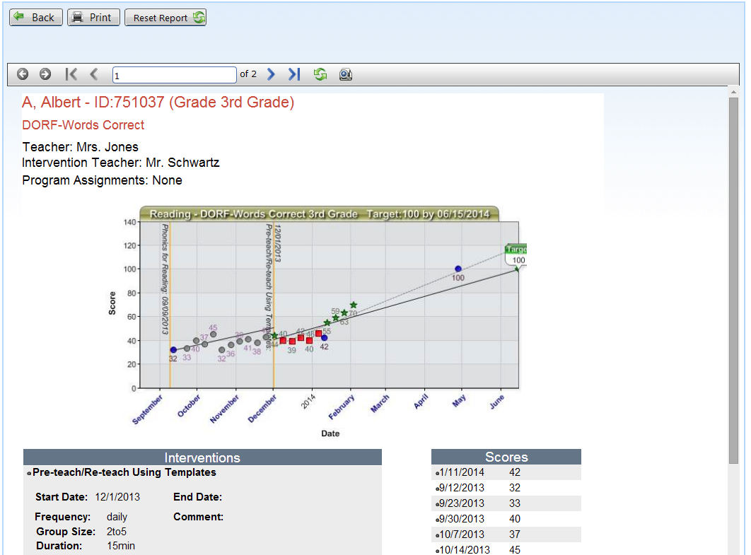
Use the arrows to go between pages in the report.
Click Print to download a PDF
The progress monitoring graph is shown along with the intervention history and scores.
3) A separate report page will be generated for each student in this list.
1) Choose the measure.
Access the Interventions Report under the Reports menu.
2) Use the arrows to move students to the Report List.
4) Click Show Report.

Student History Report
The Student History Report prints detailed information about a single student's intervention and score history across multiple years and measures. This can be useful information to evaluate a student's progress over multiple years, as part of a team meeting, or for including in a cumulative file.
1) Go to the Progress Monitoring Screen.
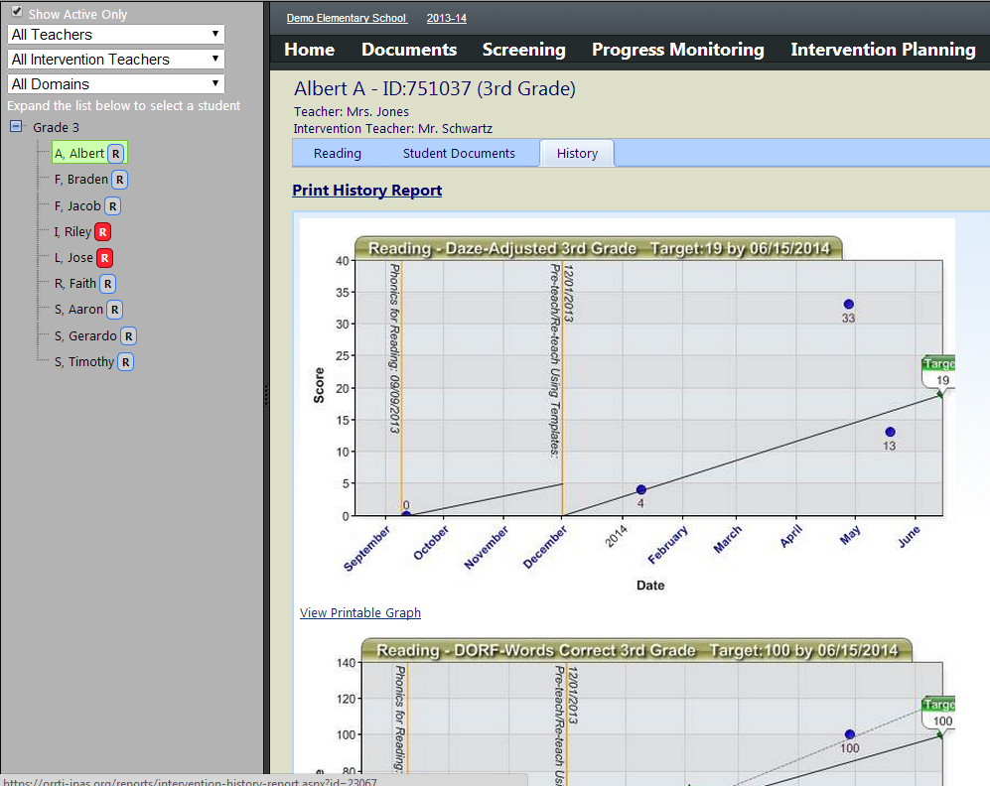
Click Print to download a PDF
4) Click here for the History Report
This page contains all the student's historical progress monitoring graphs.
3)Click on the History tab.
2) Choose the specific student.
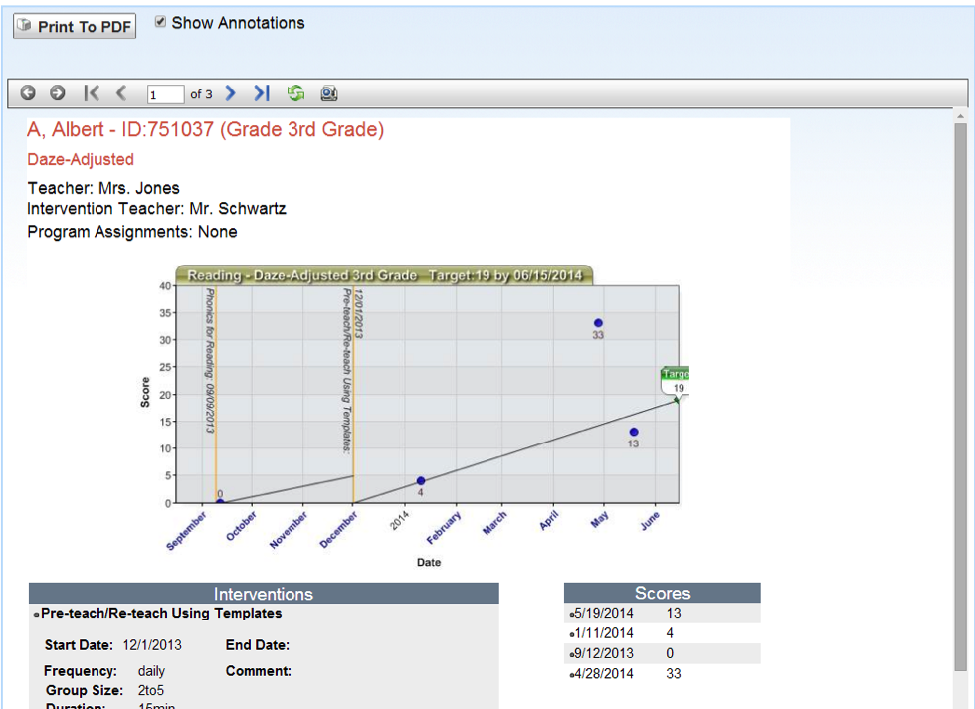
The progress monitoring graph is shown along with the intervention history and scores.
Use the arrows to go between pages in the report.

Demographic Report
The Demographic Report details the number of students, race and ethnicity, who are reaching the Benchmark and Risk Indicators defined on the Mange Test page.
This report can answer a number of questions:
- Are 80% of our students of color reaching the benchmarks?
- Is our program effectively supporting students with different racial or cultural backgrounds?
- Is the program helping underserved students reach benchmark and close the racial achievement gap?
A section is created for each ethnicity represented in the school
Additionally, comparisons between ethnic groups are readily available.
The percent of students at each support level is presented for each benchmark to measure progress.

Grade Level Report
The Grade Level Report details the number of students, by grade level, who are reaching the Benchmark and Risk Indicators defined on the Mange Test page.
This report can answer a number of questions:
- Are 80% of our students at each grade level reaching the benchmarks?
- Are there grades at which our program is accelerating student achievement of benchmarks?
- Are there grades at which our program is not keeping pace with the benchmarks?
Is the program helping underserved students reach benchmark and close the racial achievement gap?

School Report
The School Report is accessile at the district level and details the performance of students at each school in reaching the benchmarks on a single measure.
This report can answer a number of questions:
- Are 80% of students at each school reaching benchmark?
- Does the program at a specific school have a higher success rate at helping students reach benchmark?
- Does a specific school need additional support for the program?
School A
School C
School B

Adminsitration Guide

Initial Configuration
Before using IPAS, the administrator for your district must configure the system to support your district’s unique Response To Intervention protocols.

In which subjects/domains will you be tracking interventions?
What measures will be used to screen/progress monitor students?
What are the end-of-year goals for students on these measures?
Are there beginning and mid-year benchmarks for these measures?
What is your curriculum?
What are your tier II and tier III interventions?
How often will you screen students?
How will you know when an intervention needs to be changed?

With the answer to these questions, you’re ready to begin configuring the system.
The district administrator has access to the Admin page, which allows for the configuration of the system.

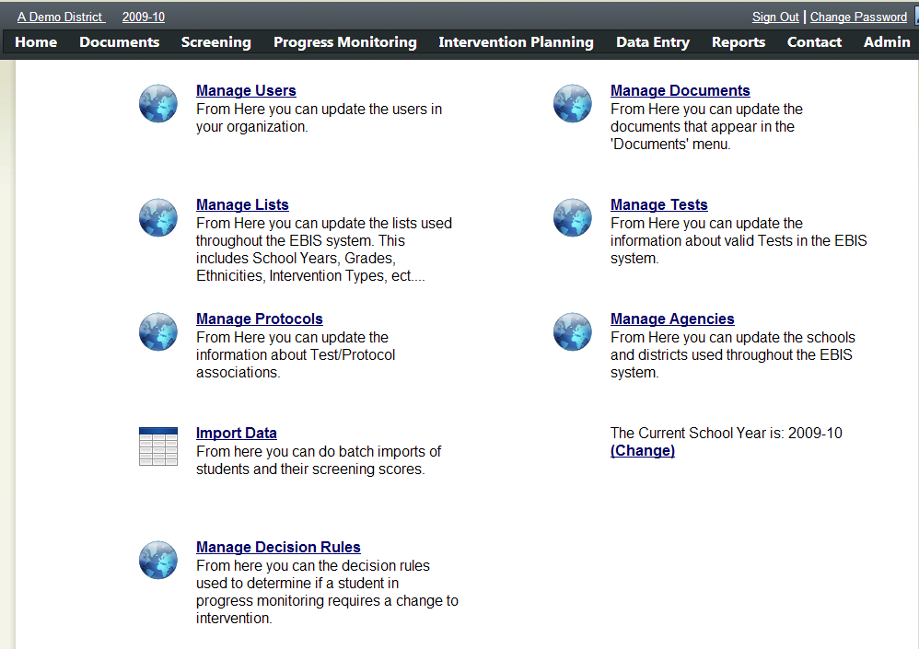
Access this Admin Screen by clicking on the Admin Link

Copying from a Default Configuration
Because there is a great deal to be configured initially, the option exists to copy an existing configuration from an existing template. After doing so, the administrator may then review the setup by continuing through this guide and checking that the copied values are appropriate.

To copy the default set-up, choose “Manage Lists” from the Admin screen. Then click on "Auto-Populate Lists” in the top right corner.

This step will not only copy the lists, but also configure tests, goals, and intervention protocols.

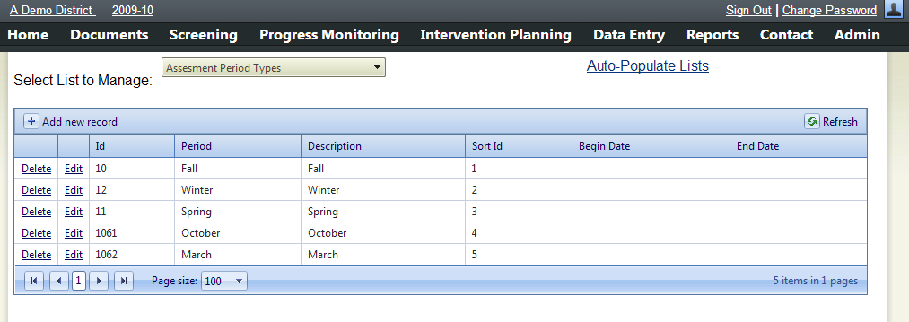
Choose Auto-Populate Lists to copy a default configuration.
Access this Manage Lists screen from the Admin Screen.

Manual Configuration

Set the School Year
The Manage Lists page allows for the customization of several terms used throughout the system. At the top is a selection box of the available lists, and on any given list new choices can be added by choosing “Add new record”, completing the available boxes in the orange row, and then choosing “Insert”.

- Choose School Year Types in the “Select List to Manage” box.
- If the correct school year is not in the list, click the “Add new Record” link.
1) Access this Manage Lists screen from the Admin Screen.
  - Enter the School Year in the School Year Column.
  - Enter a Sort ID that is 1 higher than the previous year’s Sort ID
3) Click Add new record.
2) Choose School Year Types.
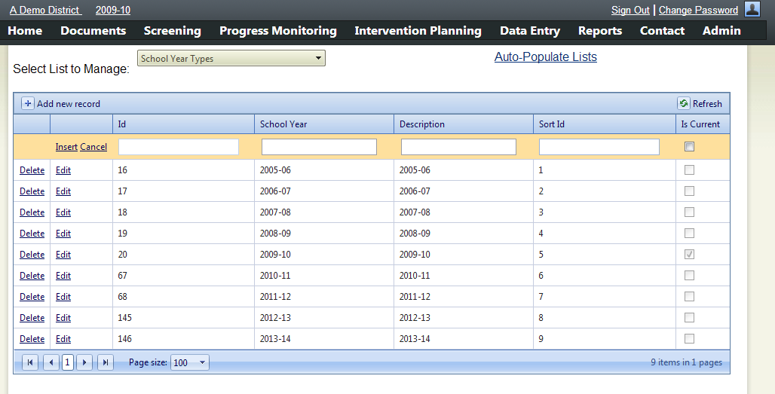
4) Enter the School Year and Sort ID and then click Insert.
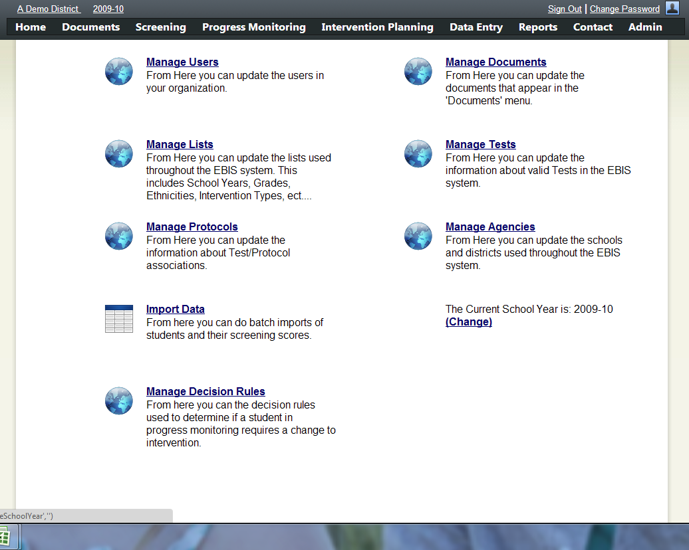
7) Change your personal school year by logging out and back in OR by clicking on the school year and changing it.
6) Click Change and set the current default school year for all users who log in from now on.
5) Return to the Admin Screen by clicking on Admin.

Define the Subject Areas or Domains to use with IPAS
The IPAS system isn't tied to any one set of tests, measures, curriculum or interventions. Originally designed to track reading interventions, the inherent flexibility has allowed it to be also be used for math interventions, writing, behavior protocols, and language acquisition. Many districts may choose to focus on Reading initially and then branch out as their experience with the system grows.
1) Access this Manage Lists screen from the Admin Screen.

3) Click Add new record.
2) Choose Domains.
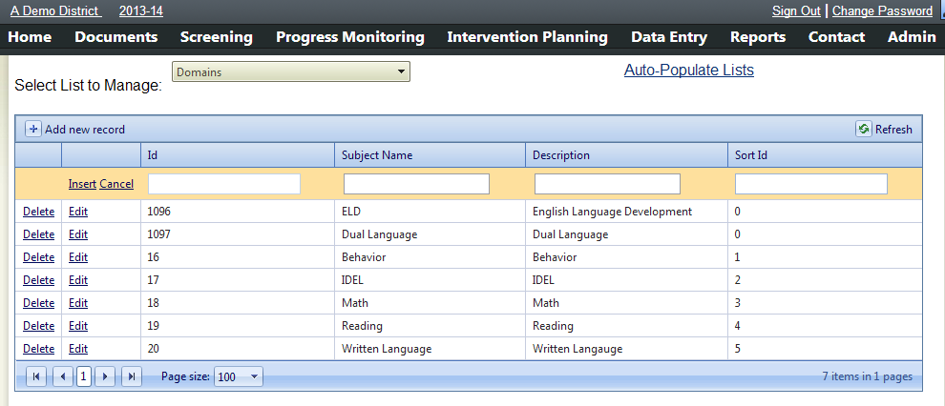
4) Enter the Subject Name and Sort ID and then click Insert.

Define Tests and Goals
IPAS allows districts to record any test, survey, or observation score that they would like to monitor over time. All scores are treated as individual tests with scores that are whole numbers. For example, Oral Reading Fluency can be defined as one test, and Oral Reading Fluency-Accuracy as another. Accuracy, generally represented as a percentage, would be recorded as a whole number such as 98 with a goal of 100.

Two pieces of information must be known to configure tests in the IPAS system: A district-wide agreed upon name for the tool, and an end of the year benchmark goal for each grade level that will use it. The goals may be identical for all grade levels, but each grade level must be entered individually.

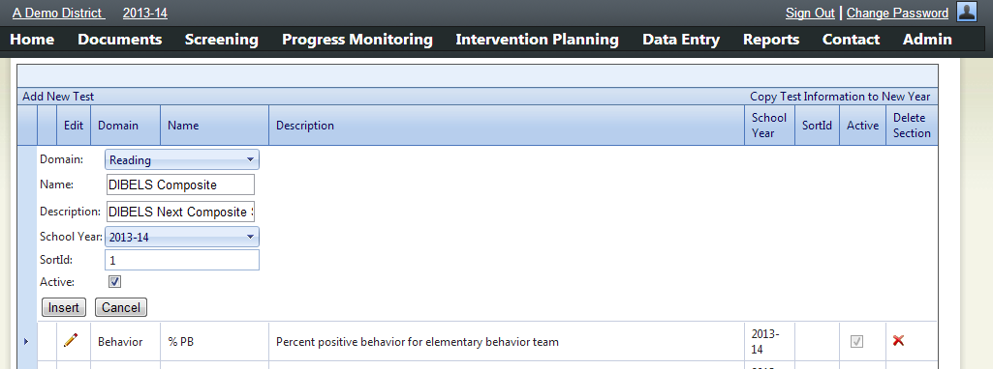
3) Choose the Subject or Domain. Enter the district-wide common name for the measure, the school year, and check Active.
Click Insert or Update to save your changes.
2) Click on Add New Test or, if the test already exists, it can be edited by clicking on the pencil icon.
2) Click on Add New Test or, if the test already exists, it can be edited by clicking on the pencil icon.
1) Access this Manage Tests screen from the Admin Screen.
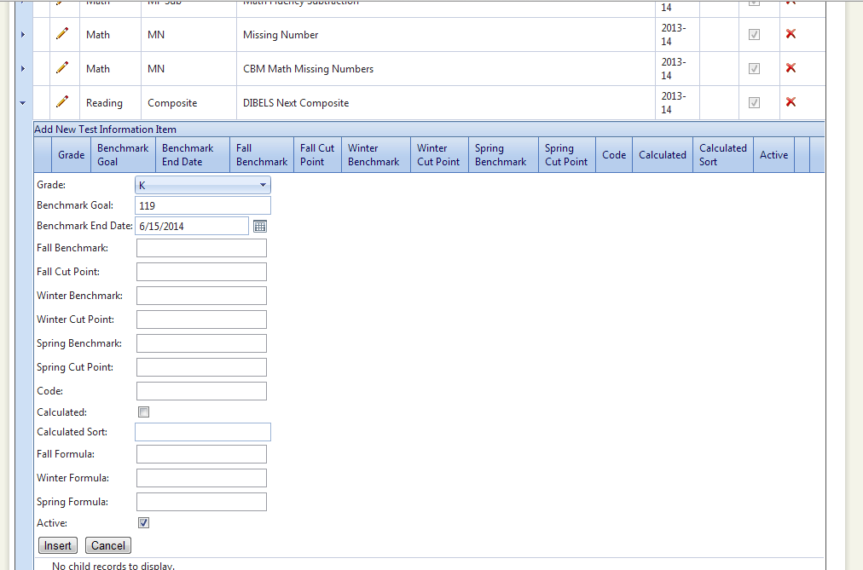
5) Click Add New Test Information Item
4) Find the new test in the list and click the triangle to see the settings for each grade.
6) Select the Grade, enter the default benchmark goal, and the date at which students are expected to reach it (the last day of school is a good default). Check Active and click Insert or Update to save your changes.
Repeat steps 5 and 6 for every grade level that will need access to this test.

Additional Settings for Creating Tests

In the previous section only the benchmark goal and end date were set for each grade level. These two settings create the default end-point for students' progress monitoring graphs and are the only two fields required to begin using IPAS to progress monitor students.

There are, however, many additional settings which can be defined.

Benchmarks and Risk Indicators
For each of the three windows, Fall, Winter and Spring, a Benchmark and a Cut Point can be defined. These can be used to set general performance levels for students. Students above the benchmark will appear as needing Core support, those below the benchmark but above the cut point will appear as Strategic and those below the cut point will appear as Intensive. When set, these will be used to generate Risk Indicators on the Screening Page, and will be used to calculate the Summary and Summary of Effectiveness reports.

Calculated Scores
At times, the results of one test may be calculated off of the scores of one or more other test. To aid in screening score entry, IPAS can accommodate these types of calculations.
By placing a unique code in the Code box (such as orf-correct), that score then becomes eligible for use in calculating other fields. For example, the Fall, Winter and Spring Formulas for ORF Accuracy might all read orf-correct/(orf-correct + orf-errors)*100. Calculations are used for both screening score entry and progress monitoring score entry.
For examples, see the DIBELS Next Composite Benchmark Calculations at the end of this manual.

Defining Curriculum, Interventions, and Protocols

Core curriculums, replacement core curriculums, intervention curriculums and behavior protocols are all defined as protocols in the IPAS system. These protocols can be assigned to individual students, and indicate unique phases in the instructional history for that student. Additionally, the Curriculum report uses this information to indicate how many students are receiving a specific protocol.
1) Access this Manage Lists screen from the Admin Screen.
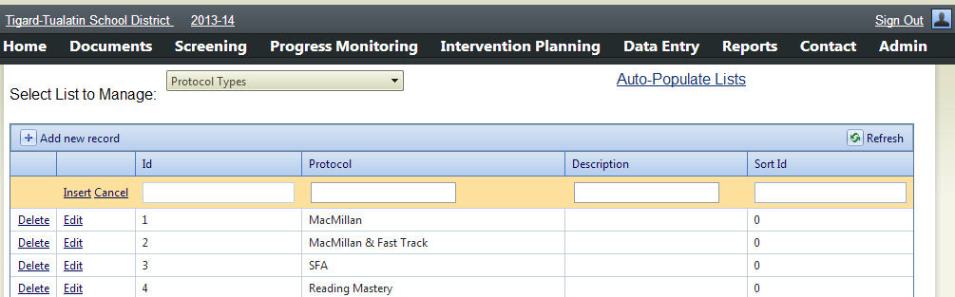
2) Choose Protocol Types.
3) Click Add new record.
5) Access the Manage Protocols screen from the Admin Screen.
4) Enter the Protocol and Sort ID and then click Insert.
Repeat steps 3 and 4 for each protocol.
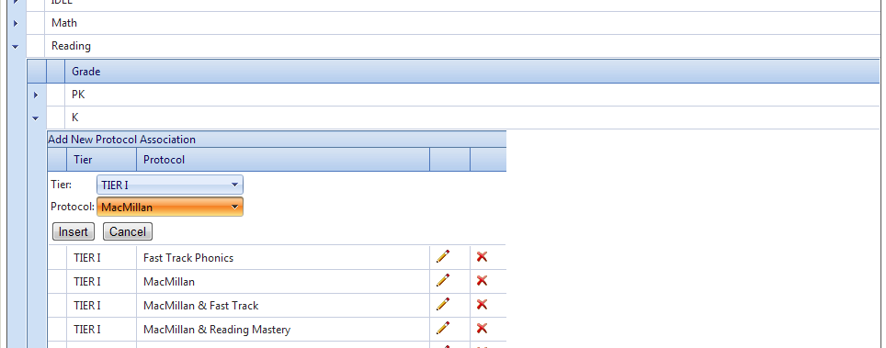
8) Choose the Appropriate Tier, and the Protocol then click Insert.
Repeat steps 6 through 8 for each protocol under each grade.
7) Click Add New Protocol Association
6) Click the triangles to expand out the appropriate Domain and the Grade.

Defining Assessment Windows or Periods

In an RTI system, it's important to do school-wide screening tests multiple times a year to ensure the integrity of the core instruction, to identify students for intervention, and to evaluate the effectiveness of the instructional program. A minimum recommendation is to test students three times a year, once at the beginning, once mid-year, and once at the end of the school year. Typically these would be defined as Fall, Winter, and Spring or Beginning, Middle and End. Those benchmarks, and additional benchmarks if needed are defined under the Manage Lists.

3) Click Add new record.
2) Choose Assessment Period Types.
4) Enter the Period and Sort ID and then click Insert.
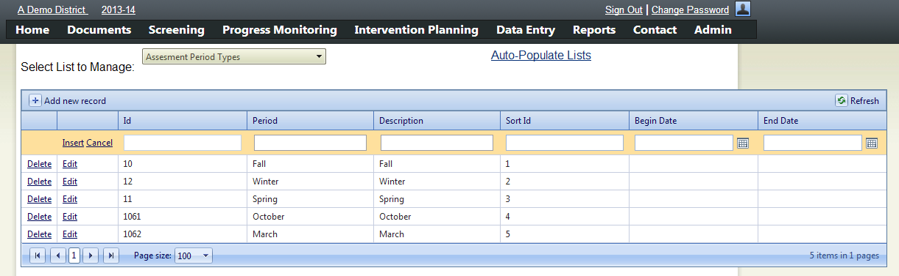
1) Access this Manage Lists screen from the Admin Screen.

Setting Decisions Rules for Changing Interventions

When a student has been receiving an intervention for a period of time, and isn't making adequate growth toward his individual goal, the IPAS system flags that intervention for review. The rules for determining what is and is not adequate growth are configurable on the Manage Decision Rules page.

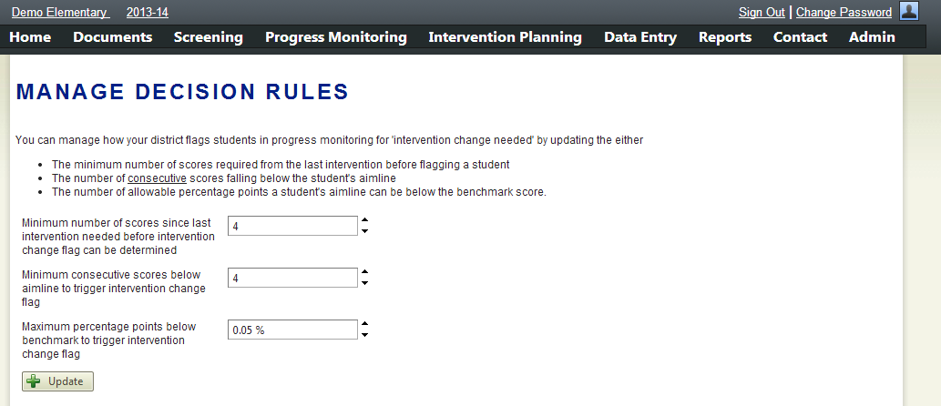
1) Access this Manage Lists screen from the Admin Screen.

Adding Students to the System
There are three ways to add students to the IPAS system.
- As part of a Test Record Upload
- As a Student Record Upload
- Through Manual Entry
If your district will be using a computer based system to administer or score the school-wide Screening Tests and that system can generate a data file, that file can be loaded directly in to IPAS and create the student records at the same time that the test data is loaded. If, however, you will be doing score entry directly in to IPAS you'll need to create the student accounts either uploading a student file or entering the students one-by-one in to the school roster.

Adding Students Through a Test Record Upload

Adding Students through a Student Record Upload
In IPAS Student data can be uploaded directly either by itself or with screening test data. Both of these uploads are done through the same file format. A template for this file can be downloaded from the import data screen. The file can be generated from another data system, but the file must be converted to Excel prior to uploading. The only difference between a Student Record Upload and a Test Record Upload is the absence of test data.
Importing students without test data allows for staff to use the system to record screening scores directly.
3) Choose the appropriate test window and year. Then click Next.
Optional information can be included such as birthdate, gender, OAKS scores, Attendance, etc...
2) Download the IPAS Excel template by clicking here.
1) Access this Import Data screen from the Admin Screen.
4) Minimum required fields to upload student roster data.
Note: If uploading Ethnicity, the text must match exactly the text under Manage Lists.

Tips:
- Data in fields must be visible. Click the triangle to the left of column A to highlight the entire worksheet, then double click between columns A and B to resize the every column at once to the appropriate size.
- Date columns must be in the Date format. Click the column header and change the formatting from General to Short Date.

Manually Adding Students to the School Roster

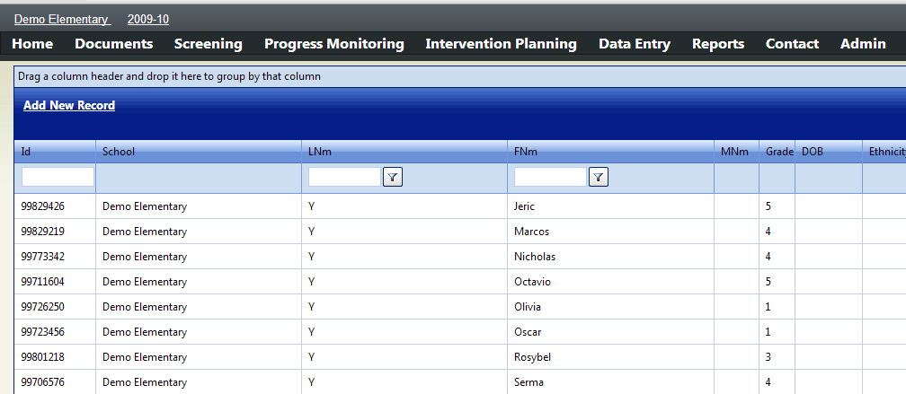
3)Click Add New Record.
1) If you have access to more than one school, click here to select the correct school.
2) Access this School Roster screen from the Data Entry Menu.
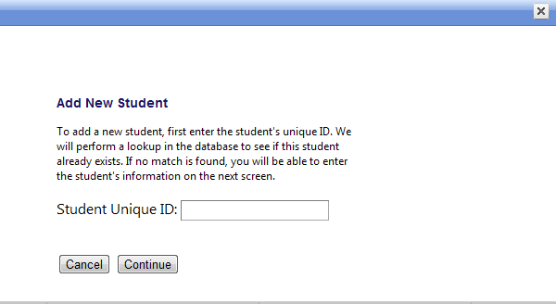
4)Enter the student's District ID Number

If the student already exists in the system, IPAS will present you with the student's information so that you can make any necessary edits. Enter the student's school and grade to enroll them in the school.

If the student doesn't exist in the system, the student box will be empty and you'll need to provide the student's name as well as school and grade.

There are a number of additional items that can also be supplied on the student record but which are not required. Teacher and Intervention Teacher can be useful for sorting data reports and delivering them to the appropriate staff. The other items, if set, appear on the Screening page alongside the students' screening scores to aid in placement decisions. Skipping the Program Assignments, OAKS Scores, Behavior and Grades do not impact the functionality of the system.
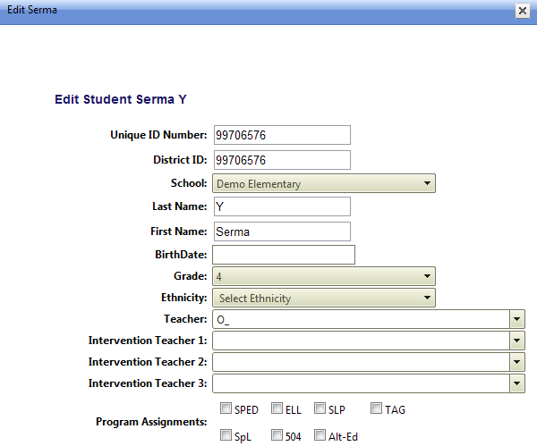
5)Enter the student's
Unique ID Number
Last Name
First Name
School
Grade
and click Save

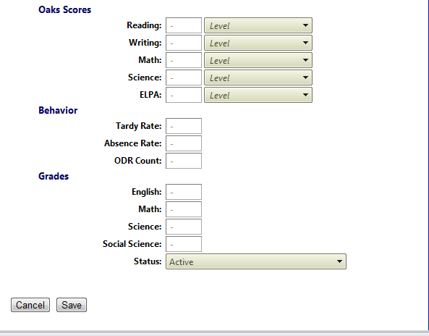

Create User Accounts for Staff

There are several layers of access in IPAS. These layers are defined as roles. The table below describes the differences from the least access to the most.
Role | Access
IPAS Teacher | Has read only access to see test scores, progress monitoring graphs and reports for all students in the school.
IPAS School Wide | Has all the access of the IPAS Teacher account and the ability to add data such as students to the school roster, screening test scores, progress monitoring test scores, and interventions within the school.
IPAS District Wide | Has all the access of the IPAS School Wide account in every school in the district.
IPAS System Administrator | Has all the access of the IPAS District Wide account plus the ability to change system settings on the Admin page.

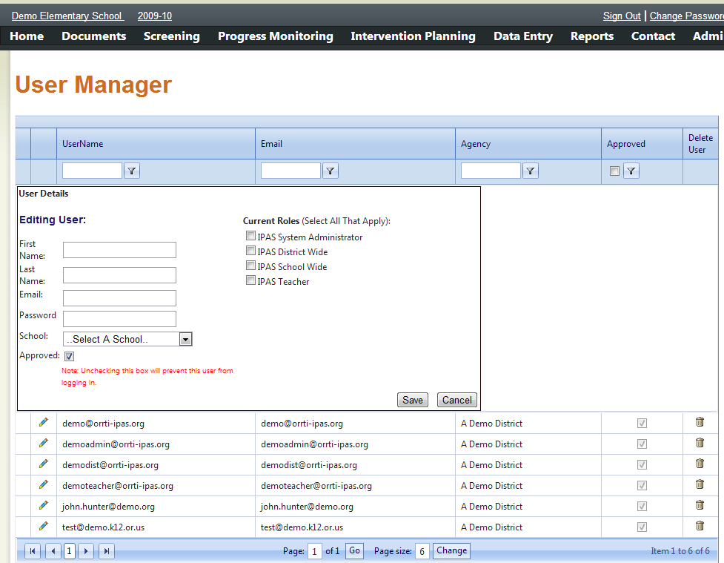
5) Click Save.
5) Select the appropriate Role.
4) Select the School (or district name if a district user).
3) Provide the user's First and Last Name, Email and a Password.
2) Click Add New User
1) Access this Manage Users screen from the Admin Screen.

Rolling Over Configurations for a New School Year
There are three steps to be taken in rolling over to a new school year:
- Configure the new School Year
- Copy Test Configurations from the Prior Year
- Add Students in the New School Year
The following pages will walk you through these steps.

Configure the School Year
The Manage Lists page allows for the customization of several terms used throughout the system. At the top is a selection box of the available lists, and on any given list new choices can be added by choosing “Add new record”, completing the available boxes in the orange row, and then choosing “Insert”.

- Choose School Year Types in the “Select List to Manage” box.
- If the correct school year is not in the list, click the “Add new Record” link.
1) Access this Manage Lists screen from the Admin Screen.
  - Enter the School Year in the School Year Column.
  - Enter a Sort ID that is 1 higher than the previous year’s Sort ID
2) Choose School Year Types.
3) Click Add new record.
4) Enter the School Year and Sort ID and then click Insert.
7) Change your personal school year by logging out and back in OR by clicking on the school year and changing it.
6) Click Change and set the current default school year for all users who log in from now on.
5) Return to the Admin Screen by clicking on Admin.

Copy Available Tests from the Prior Year
Initially the new school year will be configured with no tests. Rather than creating them from scratch they can be copied from a prior year.
1) Access this Manage Lists screen from the Admin Screen.

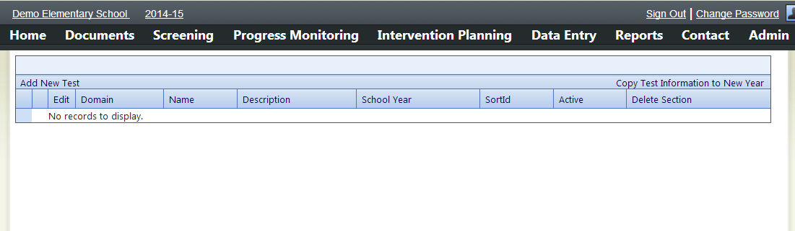
2) Click Copy Test Information to New Year

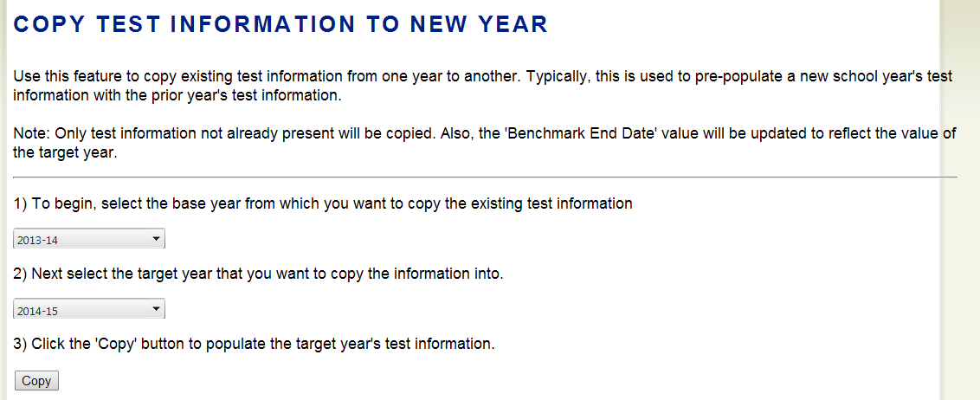
5) Click Copy.
4) Choose the year in to which to copy test configurations.
3) Choose the prior year from which to copy test configurations.

After copying test information to the new school year, edits can be made to the test configurations to accommodate any changes to tests, benchmarks, or goals. See the sections on editing test configurations.

Add Students to the New School Year
Please see the section on Adding Students to the System on page 15.

Test Administration Tools Setup

MAZE and DAZE Setup
1) Access this Manage MAZE Tests screen from the Admin Menu.

Create Passages
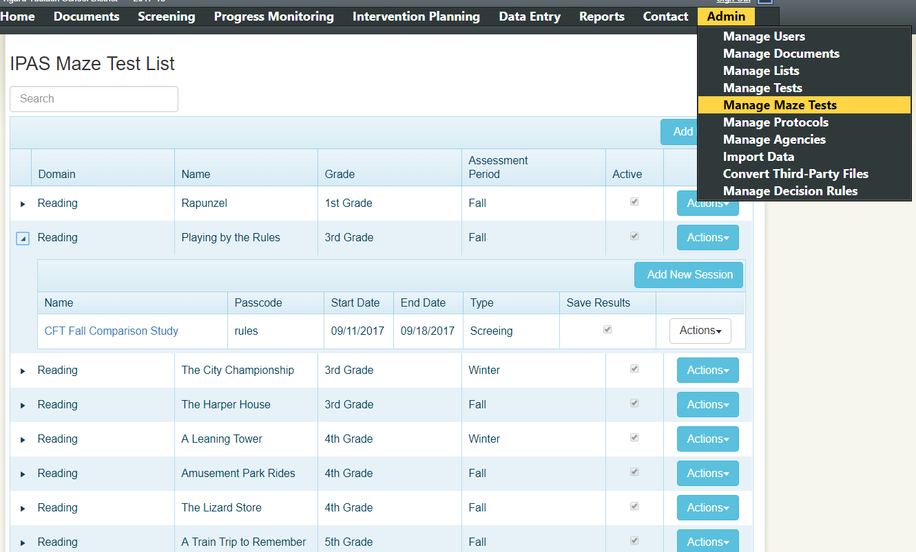
2) Click Add New
4) Set the grade and Assessment Window during which this assessment will be given. If given as a benchmark, this sets window in whichthe score will be recorded.
5) Set Number Correct and Number In-Correct. These fields set where the scores are recorded. Calculated scores which reference these will also be calculated. (see Calculated Scores)
3) Provide a unique name for the passage. This will not be shown to students.
7) Enter two practice passages which will be group administered prior to the assessment. These are in the same format.

As changes are made, the preview is updated real-time. The correct answer is bolded.

6) Enter the text to be used in the MAZE/DAZE passage. See the formatting tips below.
8) Click Save.

Format of Text
MAZE/DAZE passages are stories in which words are removed and replaced with three choices. The three choices are presented in a box and contain one right answer. The format for creating these is to place the three words in brackets and to separate them with the pipe “character”. The correct answer is preceded by an asterisk. Here is a properly formatted example from the DAZE Practice Page.
After playing in the dirt, Sam went [*home|summer|was] to wash her hands.
The Passage Text as well as the Practice Passages can be formatted with HTML.

Create Test Sessions
To take a MAZE/DAZE test, students log in to test sessions. The sessions must first be created and assigned “passcodes” or “session codes” which students will need to log in.
2) Click Add New Session.
1) Click the Triangle next to the passage to expand the list to see the list of sessions.

6) Enter a Passcode which is the Session Code students will enter to begin testing.
7) Check the update Student Scores in Database to have the scores recorded. If you want a demo or practice, uncheck this box and the score will not be recorded.
5) Select the Score Type
Screening: Will be recorded as a benchmark score in the Fall, Winter, or Spring based on the passage setup.
Progress Monitoring: Will be recorded as a Progress Monitoring Score on the date it was given.
4) Enter a Start and End Date during which the students will be able to access the test.
3) Enter a Name for the session.
8) Click Save.

Resetting Student Access
For students to log in, they only need to know the session code for the passage they’re going to take. Once the student has logged in, they are prevented from accessing that test again. To allow the student to access again, the student needs to be deleted from the test session.
1) Click the Triangle next to the passage to expand the list to see the list of sessions.

2) Click the name of the test.

3) Click Delete to remove the student’s score from the session and allow them to re-access.

3) Click the Action Button.

After deleting a record from the test session, the student’s results will remain in IPAS, but will be replaced with a new score when the student re-tests.

IPAD DAZE Delivery Comparability Study
Each year the Tigard-Tualatin School district gives 30,000+ DAZE and MAZE format assessments. Traditionally these tests are given on paper and scored by hand. Each test is comprised of 4 to 5 pages and requires several minutes to score. Across the entire school year, scoring is estimated to take around 360 hours and delays results.
To address this overhead and delay in results, we worked with our IPAS developer to create an online administration of DAZE and MAZE tests using tablet devices. This administration will allow for paperless delivery and immediate scoring of the results.
To ensure that the method of delivery does not create an unacceptable impact on student results we conducted the following comparability study between the paper and online delivery of the assessments.

Assessment Background:
The DAZE/MAZE Assessment is a 3 minute timed measure. Students are presented with a reading passage where roughly every 7th word has been removed and the student must select the appropriate word to complete the sentence. Scores can range from 0 to around 60 points. Benchmark Goals for students in the 4th, 5th, and 6th grade are around 24 points, with scores below 20 being an indication of need for intensive support. Because of this narrow range, we determined our criteria cut-off for an exceptable impact would be ±1 point.

Design:
Two schools, with similar demographics were selected to deliver two DAZE assessments to students within the same week. Both schools also have 1:1 technology in Kindergarten through 5th grade where all students have an iPad which they can take home and use through out the day. Students in 3rd, 4th, and 5th grades at these two schools took one assessment on paper and one via the ipad. Students who took both tests are said to have “paired” results. Daze-Adjusted scores were calculated for both deliveries. For the purposes of this study, we’re focused on the difference in adjusted results for a paired result.
Care was taken to distribute the method of delivery across passages to isolate the bias of the passage from the method of delivery.
 | School Demographics |  | Paper Delivery | IPAD Delivery
School A | White: 58%  Latino: 29%  Low Income: 42% | ELL: 21%  SPED: 8% | Progress Monitoring Passage 36 (PM36) | Benchmark 1 Passage (BM1)
School B | White: 61%  Latino: 25%  Low Income: 45% | ELL: 24%  SPED: 9% | Benchmark 1 Passage (BM1) | Progress Monitoring 36 Passage (PM36)

A number of administration errors led to results which were outside the range of 1.96 standard deviations of the mean difference between delivery methods. Errors included classroom disruptions during the timed portions of the test and technical issues when students used the browser’s back-button and locked themselves out of the tests. There were a total of 85 outliers which were identified and ultimately removed from the data set. The final dataset included 427 pairs of results. The results were evenly divided between students who took the BM1 passage on the iPad (213) and those who took the PM36 passage on the iPad (214).
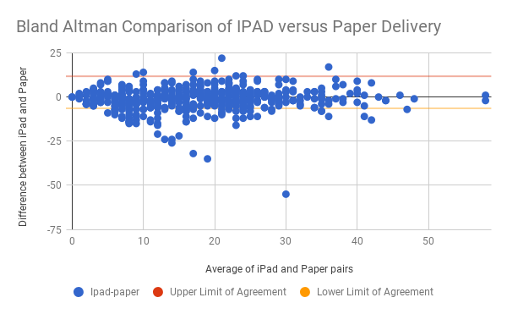

Adjustment for Passage Difficulty:
Because DAZE passages were delivered across both mediums, differences in the level of difficulty between the benchmark 1 passage and the PM Passage could be averaged from the results despite the delivery mechanism. To control for the difference in the passage difficulty, the results of one test in a pair of results were adjusted by the mean difference in scores between the passages by grade level.

Difference in passage difficulty: Average difference in DAZE Adjusted results from Passage 36 to BM 1
3rd Grade: -0.66
4th Grade: -0.83
5th Grade: +0.93

Prior to Adjustment for Item Difficulty |  |  | Following Adjusment for Item Difficulty (containing outliers)
Average of IPAD | 16.86 |  | Average of IPAD-Adjusted | 16.90
Average of Paper | 18.23 |  | Average of Paper | 18.23
Average Ipad-paper | -1.36 |  | Average IPAD-Adj - Paper-Adj | -1.33
stdev ipad-paper | 6.68 |  | stdev ipad-adj - paper | 6.59
Upper Limit of Agreement | 11.74 |  | Upper Limit of Agreement | 11.59
Lower Limit of Agreement | -6.42 |  | Lower Limit of Agreement | -6.33
Confidence Limit | 18.15 |  | Confidence Limit | 17.91
Percentage Error | 0.99 |  | Percentage Error | 0.99

Findings:
After dropping the outliers and controlling for the difficulty in passages, the average difference in DAZE-Adjusted scores for the IPAD delivery is pretty consistenly in the 0.18 to 0.25 range across grade levels. The average across all grade levels being +0.24 points. This means on average a student could be expected to do about a quarter of a point better on an IPAD delivered test than on an paper delivered test, which is well within our criteria cut-off of ±1 point. We can have confidence that student scores derived by using an iPad to deliver and score the assessment will be comparable to those derived through paper administration and manual scoring. If there is a concern that a specific students’ score has been impacted by the iPad, the recommendation is to provide an additional paper test using a new progress monitoring probe.

Average Difference in DAZE-Adjusted scores between IPAD delivery and Paper delivery
Students who took BM1 on IPAD | +0.24 Points
3rd Grade | +0.18
4th Grade | +0.27
5th Grade | +0.25
Students who took PM36 on IPAD | +0.24 Points
3rd Grade | +0.22
4th Grade | +0.25
5th Grade | +0.25
Average Difference | +0.24 Points

DIBELS Next Composite Benchmark Calculations
IPAS can calculate scores from the combination of other scores entered in to the system. The below table contains calculations that replicate the DMG specified DIBELS Next Composite Benchmarks.
Kindergarten
Fall | [first-sounds-fluency] + [letter-name-fluency]
Winter | [first-sounds-fluency] + [letter-name-fluency] + [phoneme-segmentation-fluency] + [nonsense-word-fluency-cls]
Spring | [letter-name-fluency] + [phoneme-segmentation-fluency] + [nonsense-word-fluency-cls]
1st Grade
Fall | [letter-name-fluency] + [phoneme-segmentation-fluency] + [nonsense-word-fluency-cls]
Winter | [nonsense-word-fluency-cls]+[nonsense-word-fluency-wwr]+[dorf-words-correct]+ Case when ( ( Round((Round(100.00*[dorf-words-correct]/([dorf-words-correct]+[dorf-errors]),0))/3.00,0) * 3)-50)*2 < 0 Then 0 Else cast(( ( Round((Round(100.00*[dorf-words-correct]/([dorf-words-correct]+[dorf-errors]),0))/2.00,0) * 2)-65)*3 as int) End
Spring | ([nonsense-word-fluency-wwr]*2) + [dorf-words-correct] + Case when ( ( Round((Round(100.00*[dorf-words-correct]/([dorf-words-correct]+[dorf-errors]),0))/2.00,0) * 2)-65)*3 < 0 Then 0 Else cast(( ( Round((Round(100.00*[dorf-words-correct]/([dorf-words-correct]+[dorf-errors]),0))/2.00,0) * 2)-65)*3 as int) End
2nd Grade
Fall | ([nonsense-word-fluency-wwr]*2) + [dorf-words-correct] + Case when ( ( Round((Round(100.00*[dorf-words-correct]/([dorf-words-correct]+[dorf-errors]),0))/2.00,0) * 2)-65)*3 < 0 Then 0 Else cast(( ( Round((Round(100.00*[dorf-words-correct]/([dorf-words-correct]+[dorf-errors]),0))/2.00,0) * 2)-65)*3 as int) End
Winter and Spring | [dorf-words-correct] + ([dorf-retell]*2) + Case when ((Round(100.00*[dorf-words-correct]/([dorf-words-correct]+[dorf-errors]),0))-85)*8 < 0 Then 0 Else cast( ((Round(100.00*[dorf-words-correct]/([dorf-words-correct]+[dorf-errors]),0))-85)*8 as int) End
3rd Grade - 6th Grade
Fall, Winter and Spring | [dorf-words-correct] + ([dorf-retell]*2) + (ceiling([daze-score] -(.5*[daze-errors]))*4) + Case when ((Round(100.00*[dorf-words-correct]/([dorf-words-correct]+[dorf-errors]),0))-85)*8 < 0 Then 0 Else cast( ((Round(100.00*[dorf-words-correct]/([dorf-words-correct]+[dorf-errors]),0))-85)*8 as int) End

