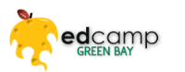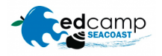 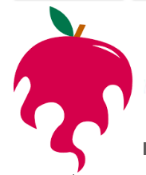 EdCamp 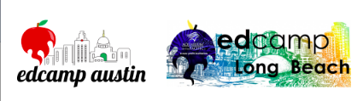

Part of the Bill and Melinda Gates Foundation & the NewSchools Seed Fund: www.edcamp.org
“ Our vision is simple! To provide an innovative form of professional development for educators in order to improve job satisfaction, increase workforce retention, and impact student learning”

EdCamp Supports include:
- $250 for breakfast
- Ed Camp in a box
- Check lists
- Swag – pins, stickers, water bottles etc.
- Current special for schools interested in Makerspaces, Maker Kits for kids.

Impact Grants are available to help with funding and continued professional learning

Want to check out a “real” Ed Camp?
EdCamp Puget Sound: May 5th Tacoma WA
EdCamp Oly – Student Voice: May 23rd Olympia WA

EdCamp

Part of the Bill and Melinda Gates Foundation & the NewSchools Seed Fund: www.edcamp.org
“ Our vision is simple! To provide an innovative form of professional development for educators in order to improve job satisfaction, increase workforce retention, and impact student learning”

EdCamp Supports include:
- $250 for breakfast
- Ed Camp in a box
- Check lists
- Swag – pins, stickers, water bottles etc.
- Current special for schools interested in Makerspaces, Maker Kits for kids.

Impact Grants are available to help with funding and continued professional learning

Want to check out a “real” Ed Camp?
EdCamp Puget Sound: May 5th Tacoma WA
EdCamp Oly – Student Voice: May 23rd Olympia WA

