Oregon Response to Instruction & Intervention
Staff Implementation Survey (ORSIS)
Consumer’s Guide

Overview

The Oregon Response to Instruction & Intervention Staff Implementation Survey (ORSIS) is a brief survey designed to help understand how a school district’s Response to Intervention (RTI) system is working to improve literacy outcomes for its students. It takes roughly 5-10 minutes to complete and is designed as an anonymous and systematic opportunity for staff to provide direct feedback to district leadership. When used as part of a continuous problem solving process, the survey results can be a powerful tool to impact change in district policy and practice. There is a survey for elementary school staff and a separate survey for secondary school staff (e.g. middle and high school).

Purpose

ORSIS can help school districts to:
- Evaluate fidelity of implementation of their multi-tiered system of literacy support at the district and school level.
- Evaluate the level of implementation and understanding among various stakeholder groups in the district (e.g. teachers, administrators, non-certified staff, etc.).
- Use data to determine areas of strength to celebrate, and areas of need to target for systematic and targeted professional development

Distributing ORSIS to Staff

The survey should be distributed to all school/district staff that provide or support instruction for students. This should include, but is not limited to:
- General education and Special Education Teachers
- Administrators (e.g. principals, vice principals, curriculum directors, special education directors, etc.)
- Other certified Staff (e.g. reading specialists, instructional coaches, school psychologists, etc.)
- Non-certified staff (e.g. paraprofessionals, instructional assistants, etc.)

To distribute the survey, please email district staff, asking them to complete the short online survey. Survey responses will be automatically graphed, with reports available on the OASIS system, accessed through the ORTII website. All responses are confidential and will be aggregated in reporting.

Below is sample text for the email to be sent to all instructional staff in your district. Please contact Dr. Jon Potter (jpotter@ttsd.k12.or.us) with questions regarding this survey.

_____(District Name) Staff,
As part of the RTI process, it is important to get your input on the current status of implementation at our school. The Oregon RTIi Staff Implementation Survey (ORSIS) will provide valuable data that will be used to improve education for all students in our district. Please go to (http://www.orrti.net/orsis_responses/add0) and complete this short, 5-10 minute survey. Please complete you survey by _____(one week from today). The data will then be analyzed and shared with you on _____(at the next inservice or via email).

Thank you in advance for completing the survey.

Sincerely,
Interpreting your Results

Results from the ORSIS provide a general view of your staff’s buy-in, knowledge, and implementation of the RTI process. When interpreting results please keep the following in mind:
- Results can be viewed at the district or individual school level
- Review the District Wide Demographics graph at the top of the report to determine if staff that took the survey are representative of your staff that implement your RTI system.
- All questions relating to Core Instruction reflect only the answers from General Education Teachers.

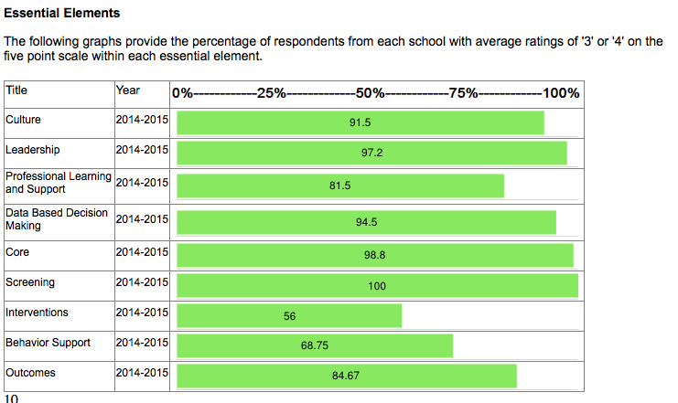
The Essential Elements Graph at the top of the report provides an overview of how staff answered questions related to the 9 components of RTI. These graphs provide the percentage of respondents with average ratings of '3 (Somewhat Agree)’ or '4 (Strongly Agree)' on the five-point scale within each essential element. This reflects the percentage of respondents who generally agree with questions related to that component. A higher percentage indicates a higher level of staff buy-in, knowledge and implementation. Conversely, a lower percentage indicates that staff generally has a lower level of buy-in, knowledge, and/or implementation of that component. Essential elements with low percentages should be the focus of further analysis to determine possible areas of need. See the example below:
Area of Strength
Possible Area of Need
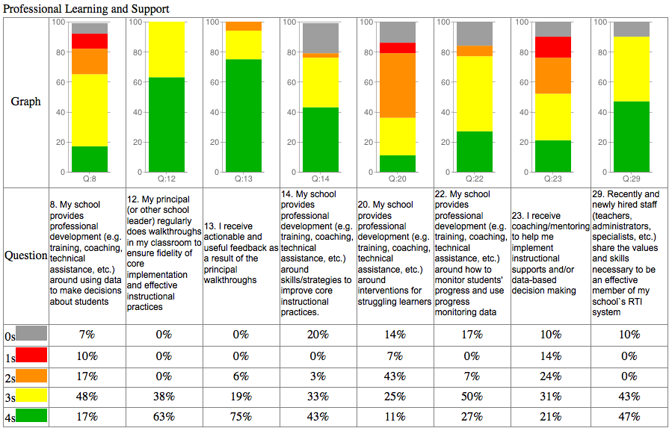
After reviewing the Essential Elements Graph, a review of how respondents answered individual questions within each component provides a deeper look at relative strengths and relative areas of need

Relative Strength

Relative Area of Need

