Punctuation Chart/Tabla de Puntuación
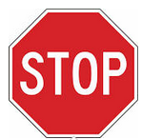 | . | Period | Stop
 |  | Punto | Detente/Para
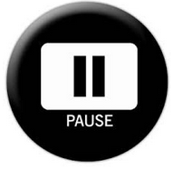 | , | Comma | Pause
 |  | Coma | Breve pausa
 | ?  ¿? | Question mark | Voice goes up
 |  | Signo de interrogación | Vamos subiendo nuestra voz
 | !  ¡! | Exclamation mark | Voice is loud and excited
 |  | Signo de exclamación | Nuestra voz es alta y muestra emoción
Brown, Sanford & Morales-Soto (2019)

This project is supported by the U.S. Department of Education, Office of Special Education Programs (Award Number H326M16008). Opinions expressed herein are those of the authors and do not necessarily represent the position of the U.S. Department of Education

