**I see the ___________.**

**I see the ___________.**

**I see the ___________.**

**I see the ___________.**

**I see the ___________.**

**I see the 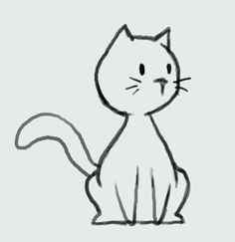.**

**I see the 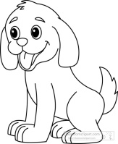.**

**I see the 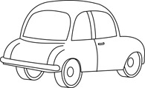.**

**I see the 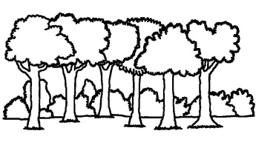.**

**I see the**  .

**I see the 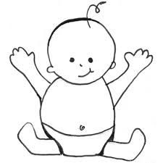.**

**I see the** **.**

**I see the**  