concerned
schedule
ruined
glorious
studio
feast
yanked
model
smeared
streak
worried
a set time for things to
happen
destroyed
wonderful
artist’s workroom
large meal
pulled hard
small copy or version
messy or blurry
to move quickly

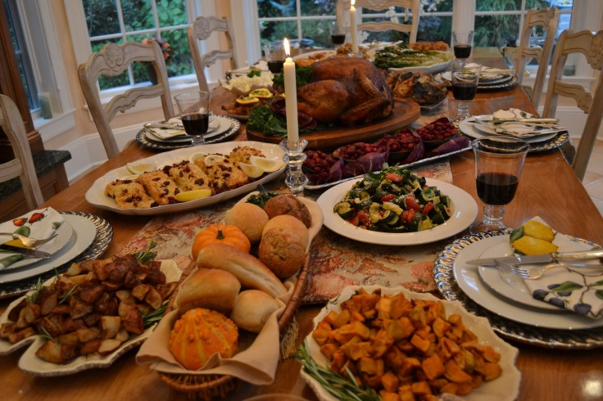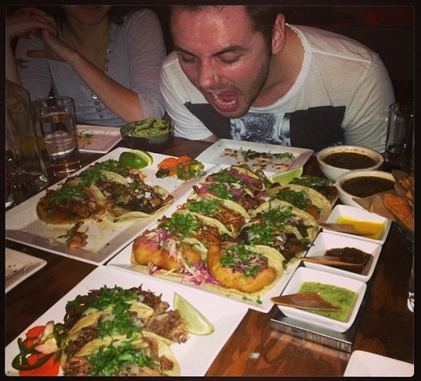
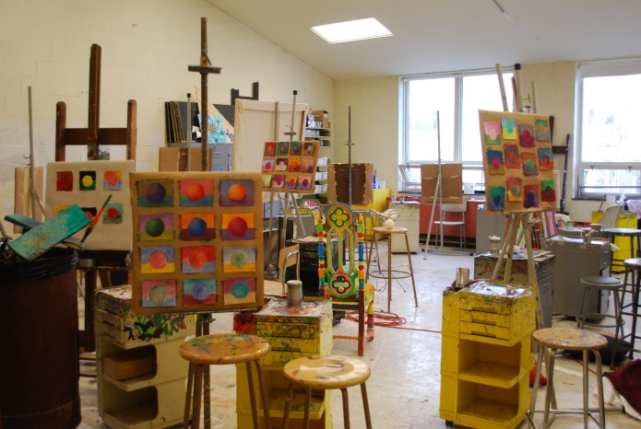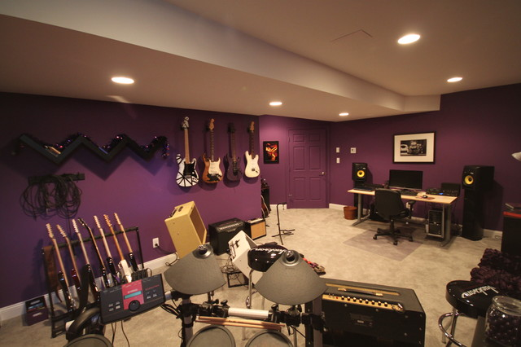
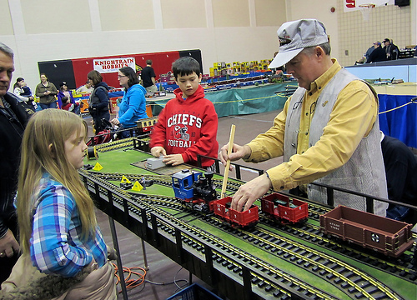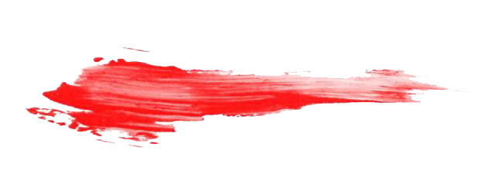
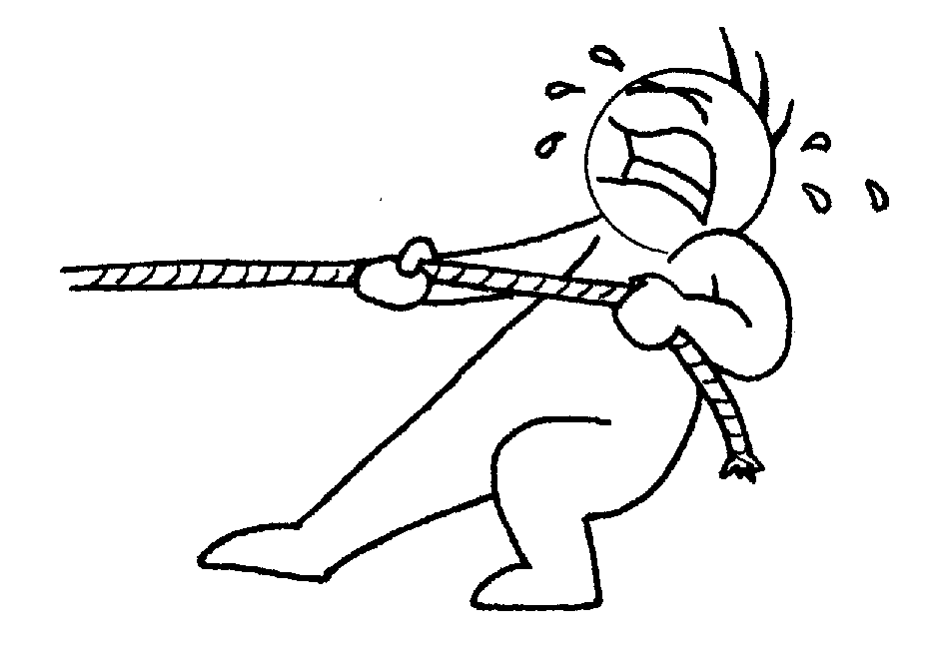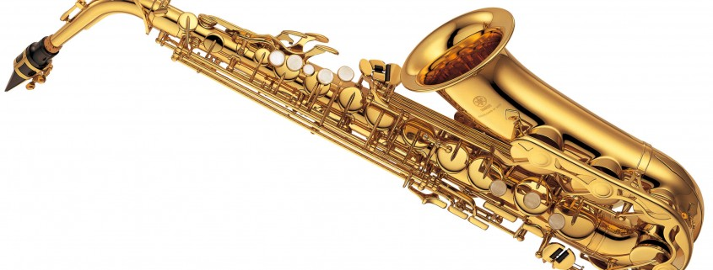
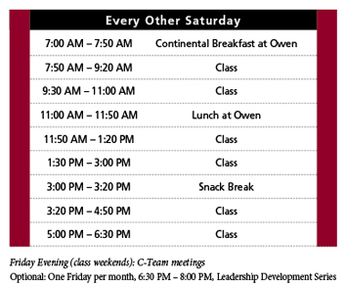

T192 Domain vocabulary
aesthetics
craftsmanship
exhibition
representation
pleasing qualities and beauty of something, such as art
ability to make things by hand
showing or public display of something, such as art
something that stands for something else
