**pounding**

**bend**

**reach**

**damage**

**prevent**

**beware**

**flash**

**equal**

**crashing**

**to cause to curve**

**to get as far as**

**harm or hurt**

**stop from happening**

**be careful**

**a quick burst**

**the same as**

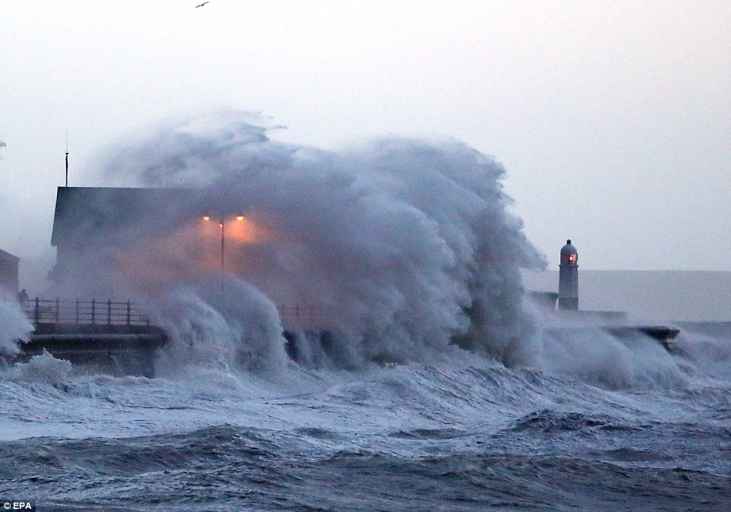

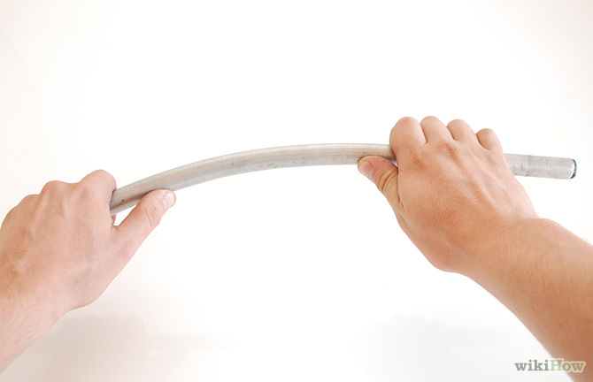

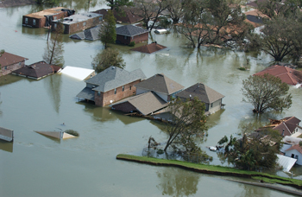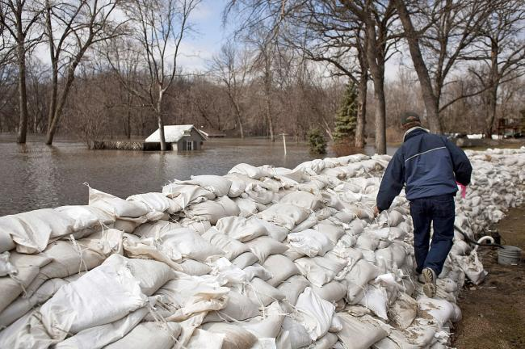

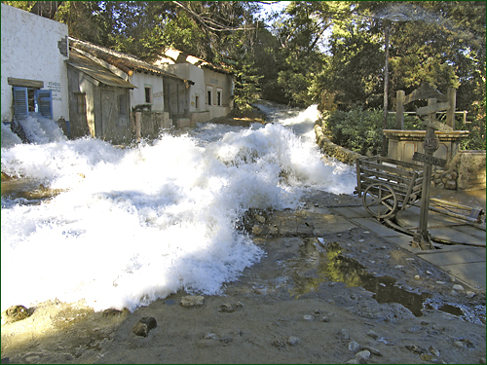

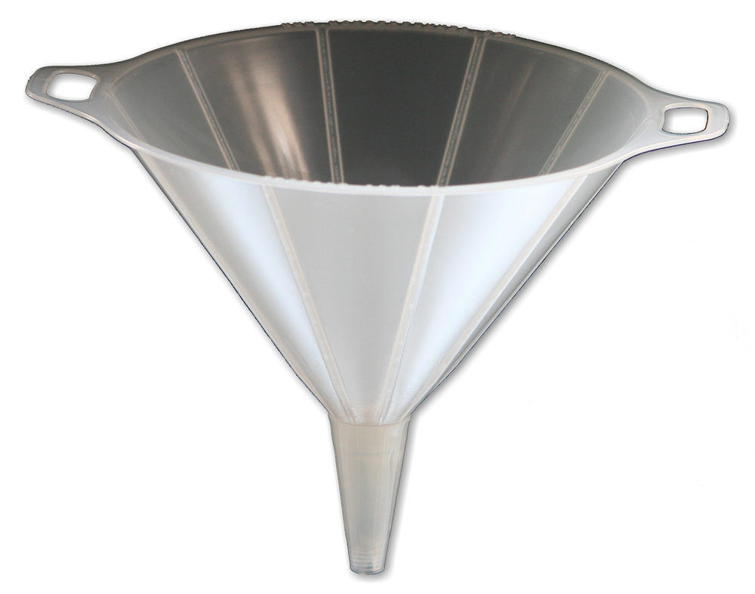

**T254 Enrich vocabulary**

**meteorologist**

**broadcast**

**preparation**

**evacuate**

**scientist who tells us about the weather**

**to send sounds and pictures by radio or television**

**get ready in advance**

**leave a place**

