faraway
village
crisp
smudge
peeked
edges

the outside parts of an area
looked quickly and secretly
make something blur or smear by rubbing it
a long way from where you are, very distant
cool, fresh, and dry
a small town usually in the country
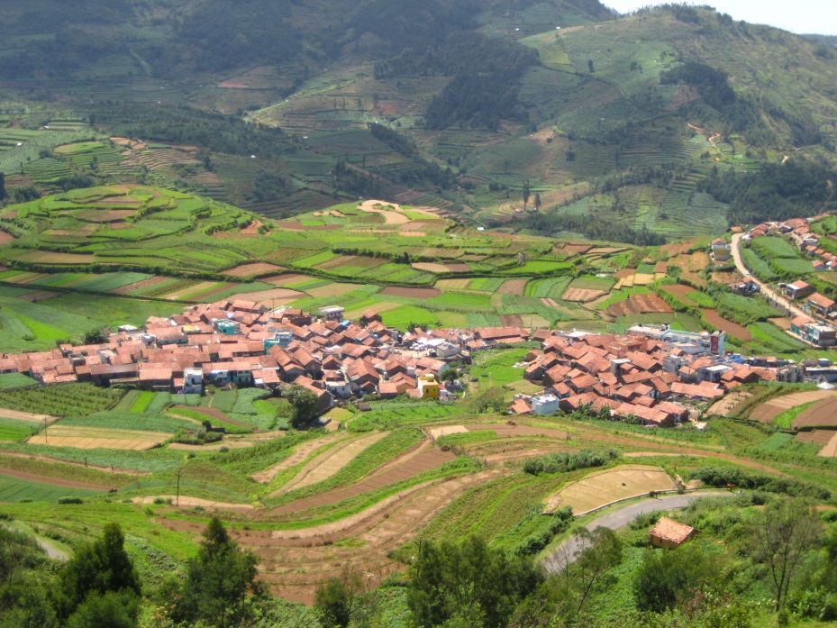
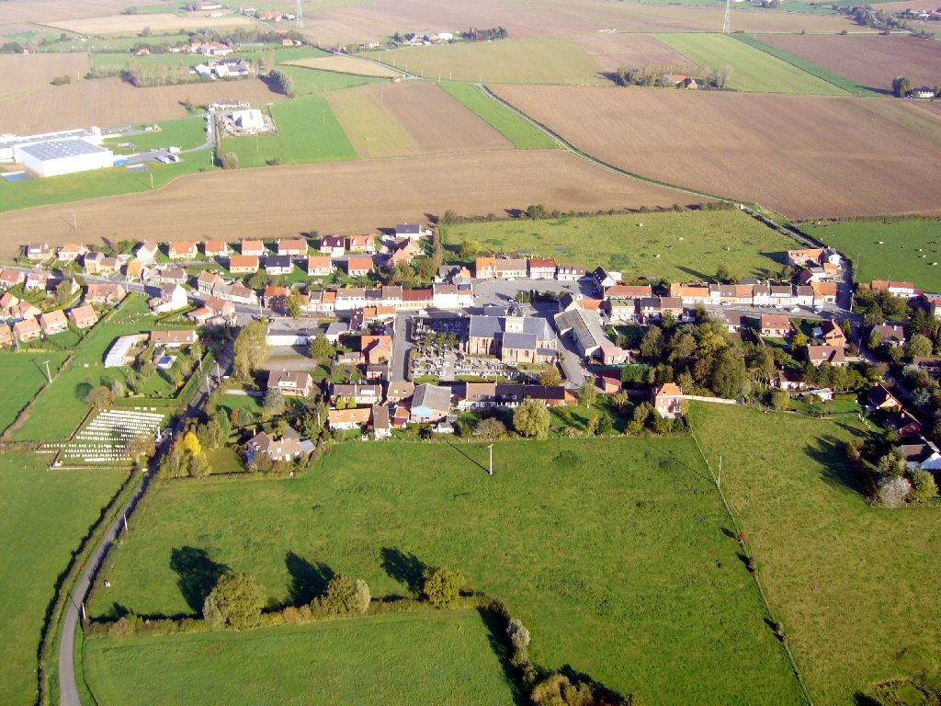
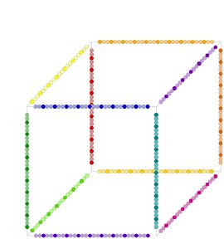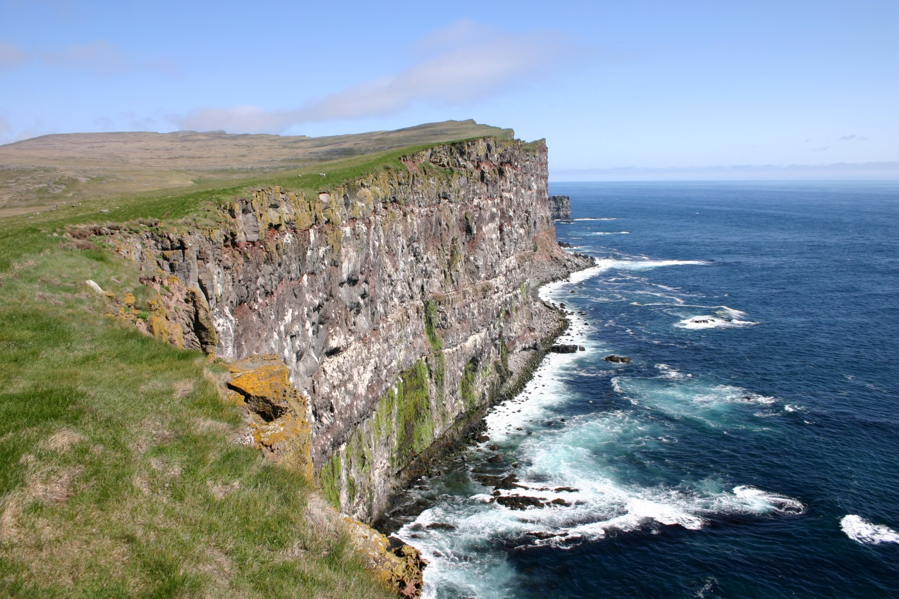
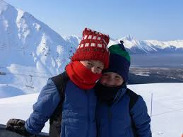

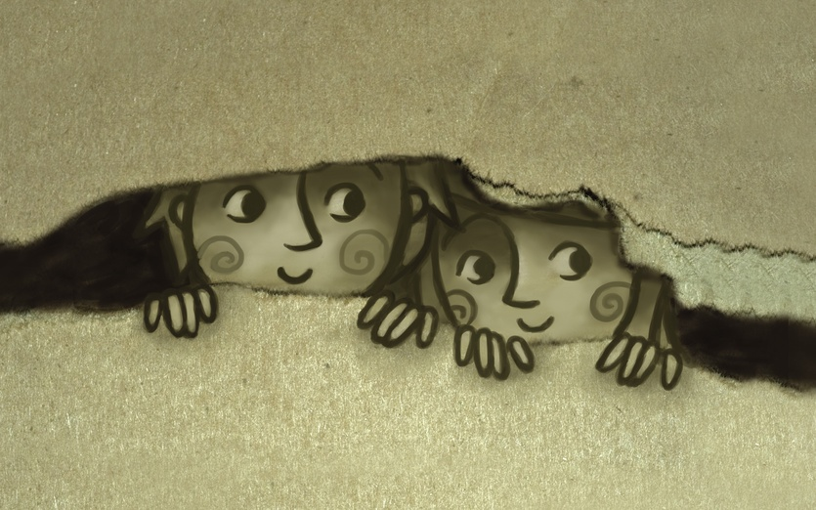

T250 Enrich vocabulary
chorus
group singing together
enthusiastic
really like something
strum
brush strings with fingers
admire
think it is wonderful
T266 Domain specific vocabulary
composer
person who writes music
percussion
sounds made by hitting instruments

