It’s ALL about the Core!
The Prevention That Avoids Intervention
Jenice Pizzuto 2019

Why do we need a core? ______________________________________________

A core Reading program provides a system of instruction for students as they move through grade levels.

RTI begins with General Education
- Teachers don’t fail students, systems do.
- RTI is a system for differentiation of instruction!
- RTI is a system that is predicated on the general education teachers’ skill and knowledge of instruction, assessment, curriculum, and children.

How is instruction organized?
A core Reading program has standards of practice across the district and grade levels that provide guidance and clarity as to the expectations for instruction.

Why?
- Time is precious – protect it!!!
- Your core program is written for at least 90/110 minutes (450 minutes/week)
- Oregon K-12 Literacy Recommendation
Provide at least 90 minutes of uninterrupted reading instruction using the core reading program to all students.
- Research shows that students need a minimum of 90 minutes of uninterrupted reading instruction with the core reading program. Providing at least 90 minutes of instruction gives students the best opportunity to receive instruction on basic skills they need to be successful readers. The 90-minute reading block must be uninterrupted, meaning there should be no assemblies, lunch count, attendance count, recess, etc., that would interfere with instruction during that time.
- For EL’s core is 90/110 minutes + ELD time

Struggling Readers in Core
- They need the most instruction.
- Need to be exposed to grade level material.
- Just because there is a deficit in one area, does not mean there is a deficit in all areas of reading.
- If they miss grade level material, they will never catch up.
- Interventions are limited in scope.

Time Done Well Matters Most
- Limit interruptions
  - Lunch count
  - Attendance
  - Assemblies
  - Limit transitions
- Dense
- Use of Evidence Based Practices
- Differentiated
- Students actively engaged

Why Align Materials?
- The whole school has:
  - A common language
  - A common goal and
  - And common tools
What do the Materials Address?
- The Big 5 of Reading
- The scope and sequence
- Common Core State Standards
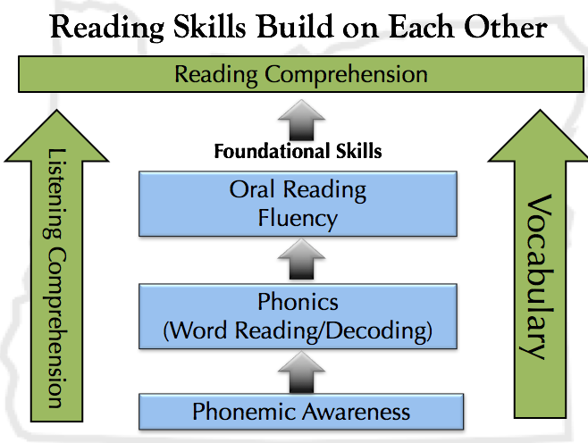

Scope and Sequence
- We want to be sure that we know what has and what will be taught.
- Mastery of skills looks different at all levels
- Repeated opportunities to learn

Instructional Design
Features of well-designed programs include:
- Explicit and systematic instructional strategies

- Coordinated instructional sequences
- Ample practice opportunities
- Aligned student materials
- Culturally appropriate

Explicit instruction works for everyone

Explicit instruction is a systematic instructional approach that includes a set of delivery and design procedures derived from effective schools’ research.
~Ideas That Work

Instruction that is Engaging
- Frequent responses are elicited
  - Things students say
  - Things students do
  - Things students write
- Responses are monitored
- Positive and corrective feedback is given
Design of instruction
- Organized and focused
- Goals that can be articulated by students
- Review and build background knowledge
- Review at the end of the lesson
- Scaffolding
- Includes instructional routines
Delivery of Instruction
- Require frequent responses
- Monitor student performance closely
- Provide immediate affirmation and corrective feedback
- Deliver instruction at a brisk pace
- Help students organize knowledge

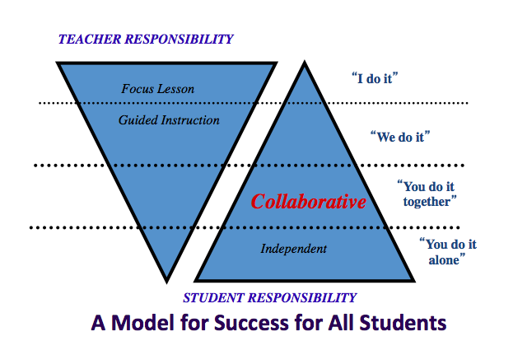
Fisher, D., & Frey, N. (2008). Better learning through structured teaching: A framework for the gradual release of responsibility. Alexandria, VA: Association for Supervision and Curriculum Development.

Differentiation during core
- What instructional strategies are to be used?
- When is direct instruction necessary?
- When and how do you get more?

Notes:

