How to input rate and accuracy scores into EasyCBM during the Benchmark Window
In the measures tab, choose the grade level/teacher info to enter in the score. Next choose the item-level data vs total score. That gives you the option of entering in the total words read and # or errors. The CWPM are automatically calculated.

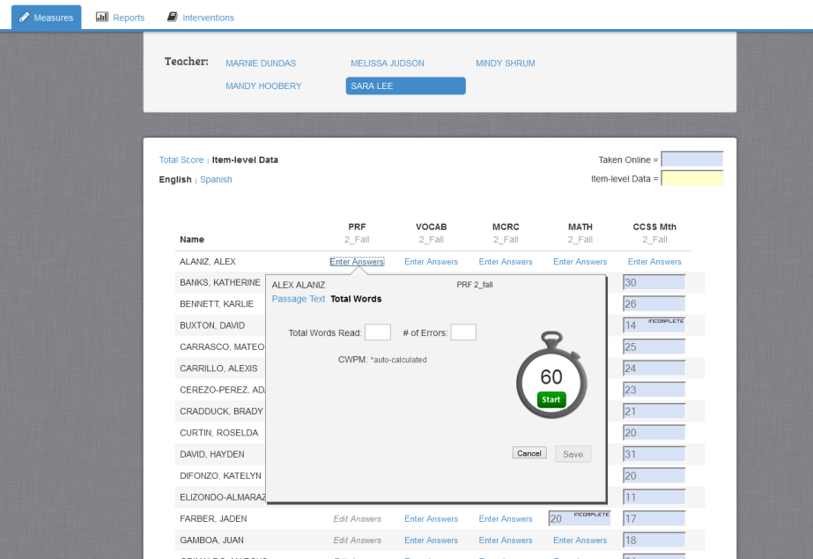

You can access student’s rate and accuracy scores when looking at their individual graphs if you entered the data in correctly during the benchmark window.
