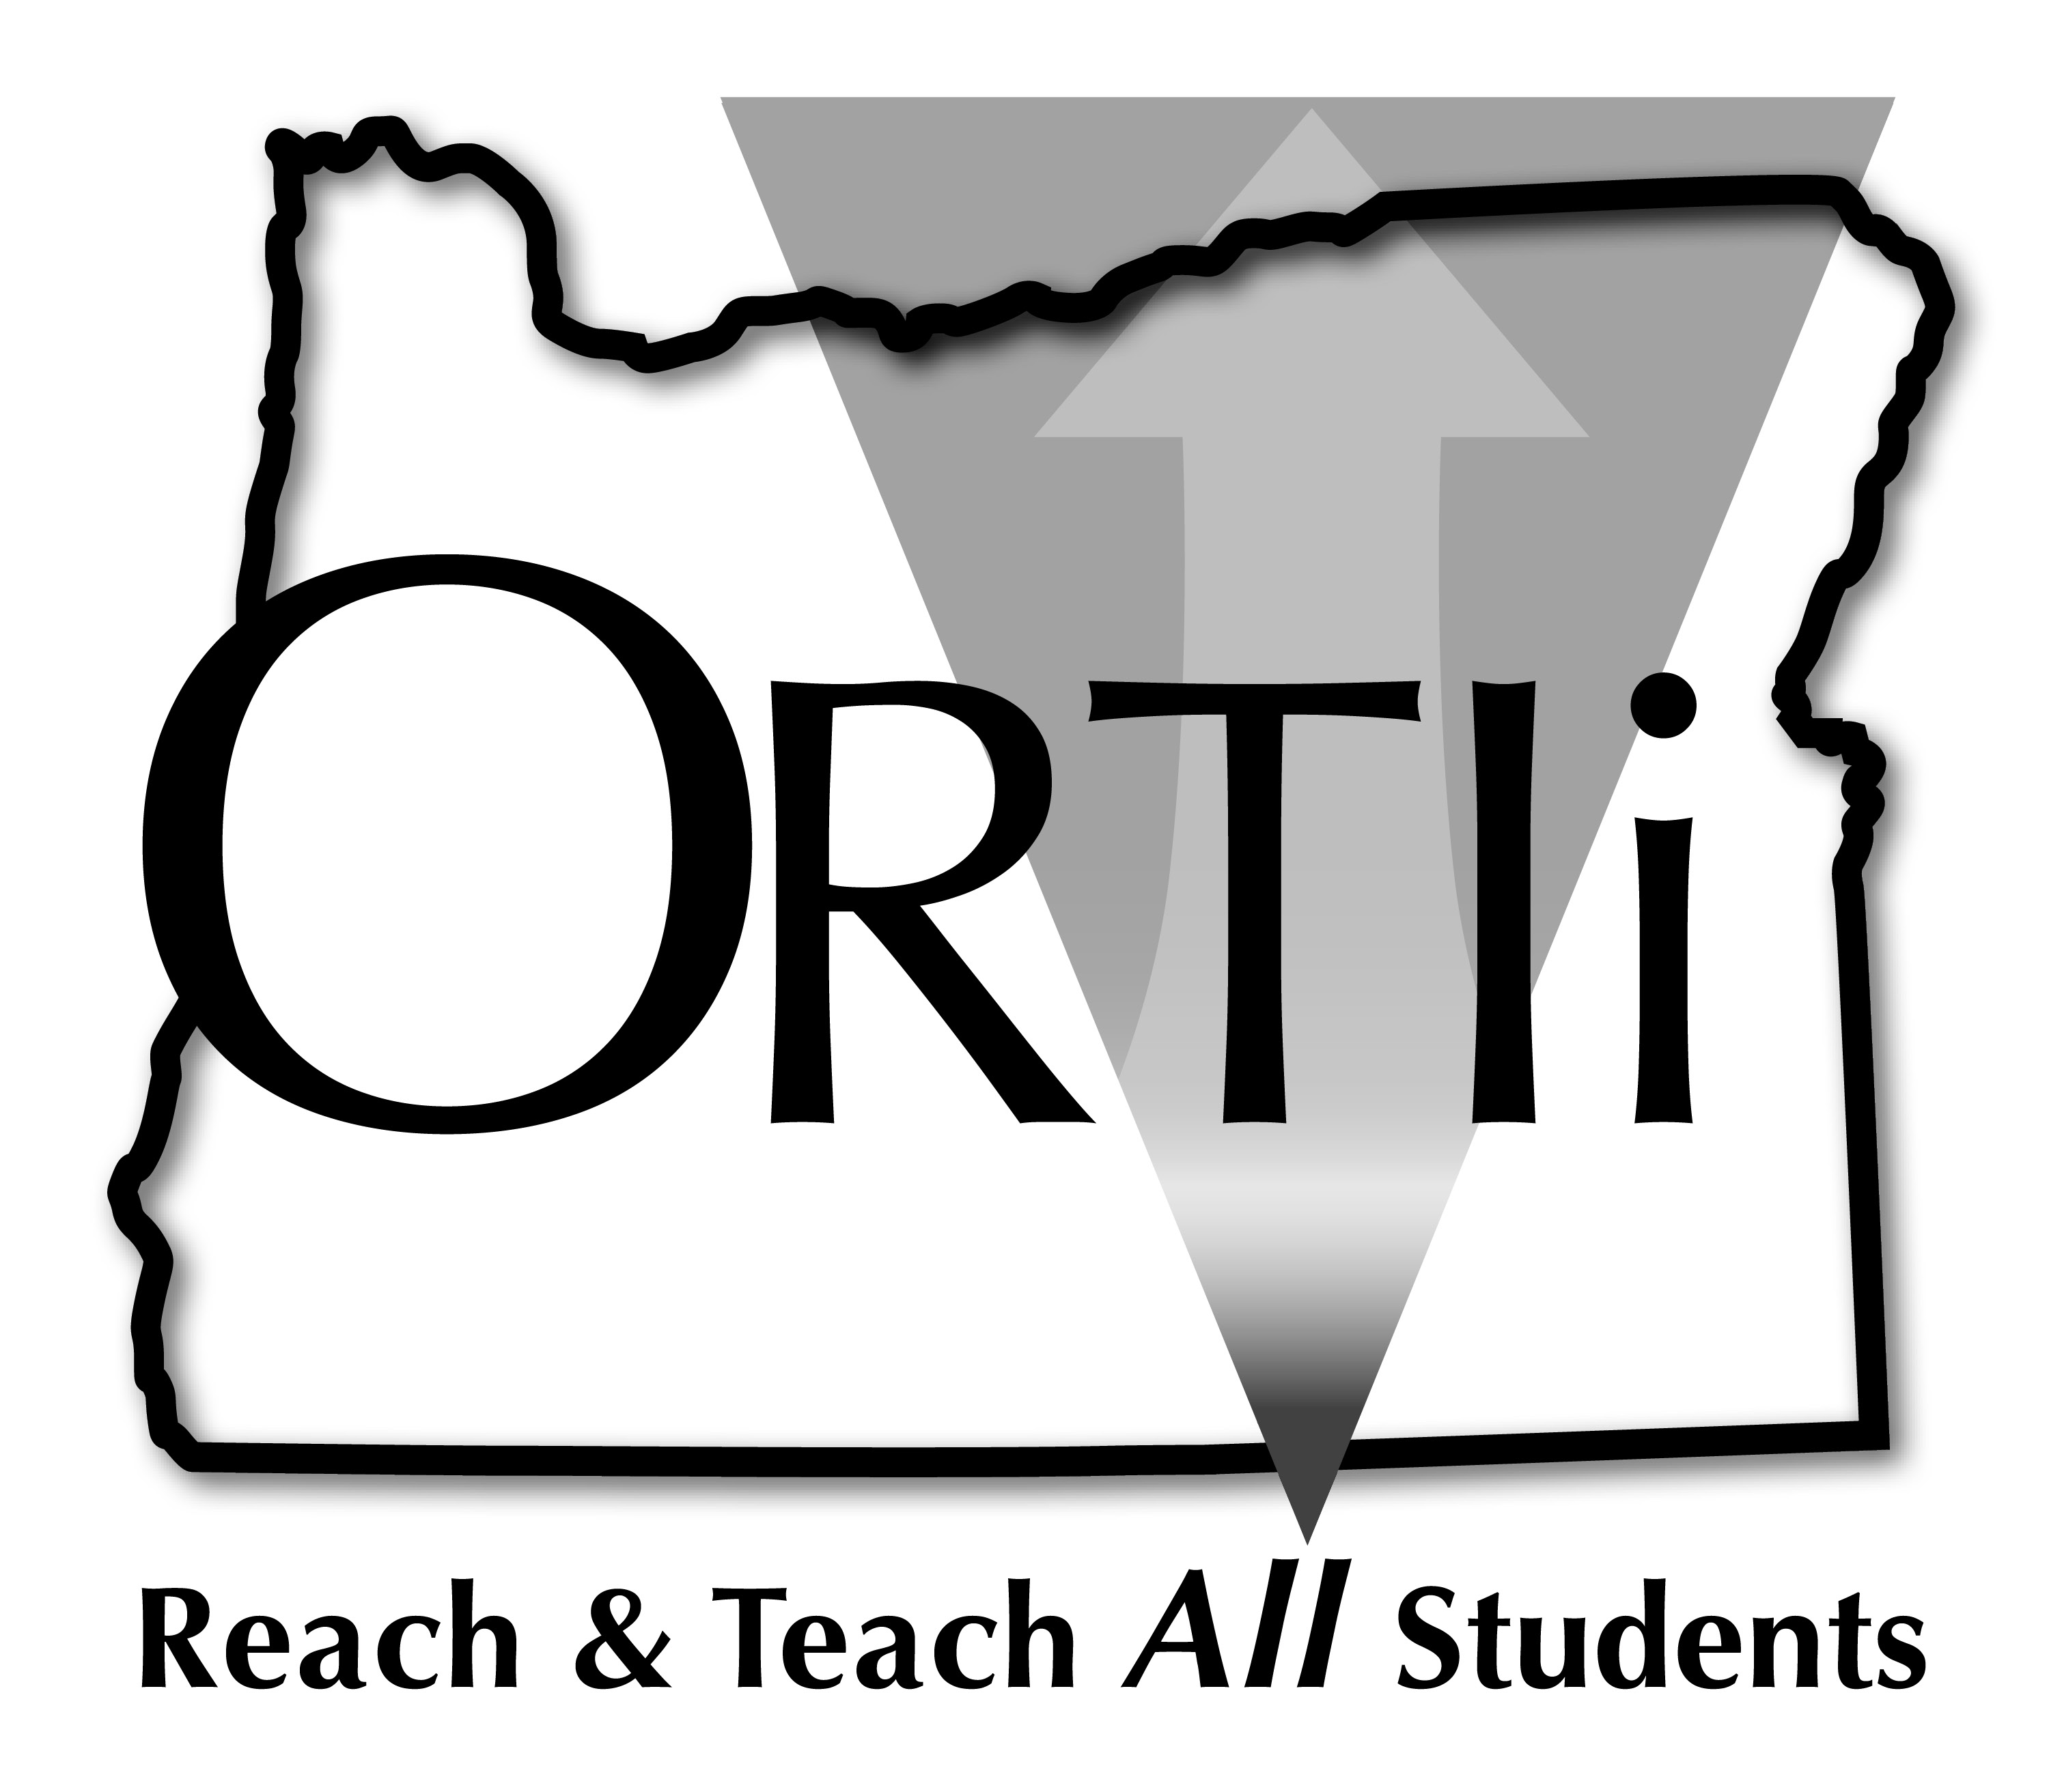
District Tier 1 Data Review

Team Members: Date:
Step 1: Problem Identification
What are our student outcomes?
(Review district and school level outcome data)

- Are we making progress, staying the same or losing ground?

- Are our needs district-wide or just in some school/s (grades)?

- What are areas of success and what are areas that need support?

Step 2: Problem Analysis
How does our implementation support our outcomes?
(Inspect what you expect!)
(Review fidelity/implementation data for standards of practice at the district and school level)

Curriculum: How do the materials we use support student learning?
- Are we following our standards of practice and/or do we need to make adjustments?
  - How are we using whole group instruction to support student learning?
  - How are we using small group instruction to support student learning?
  - How are we using independent work to support student learning?
- Is our curriculum meeting the needs of the grade level or do we need to make adjustments?

Instruction: How does the instruction we plan and deliver support student learning?
- Are we consistently using our district’s Standards of Practice for instructional strategies and/or do we need to do more of the following?
- Direct instruction in skills and strategies • Engagement
- Consistent instructional routines • Background knowledge
- Practice • Oral language

Environment: How do the environment and structures in which we teach support student learning? (Are we setting up our students for success?)
- Is classroom management supportive of student learning or does it need to be strengthened?
- Is the physical environment of classrooms conducive to student learning or does it need to be adjusted?

System Capacity: How do our system structures support student learning?
- Are we providing sufficient professional learning and coaching?
- Are we hiring the right staff?
- Does our culture support RTI?
- Does leadership support RTI?
- Does our data-based decision making support our decision making?

Step 3: Plan Development
What are our district priorities for implementing RTI? What are the barriers?
Do we have the capacity to implement our priorities? Review resources (are we providing sufficient funds to do the work?
How are we communicating our priorities to the superintendent, administrators, staff and students?
Who is facilitating this work?

Step 4: Plan Implementation and Evaluation
What are our student outcomes?
(Review district and school level outcome data)

- Are we making progress, staying the same or losing ground?

- Are our needs district-wide or just in some school/s (grades)?

- What are areas of success and what are areas that need support?

- Continue with Step 2 (Problem Analysis)

