District Equity Activity

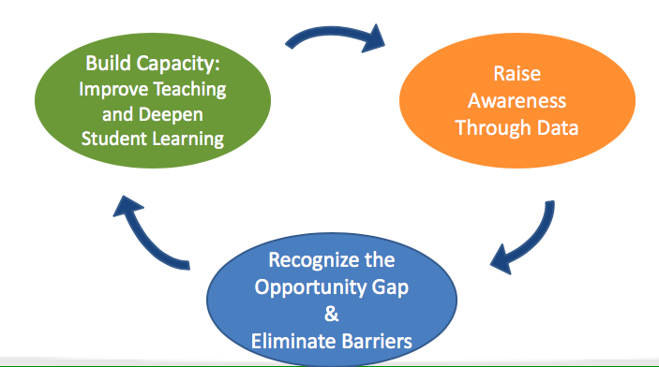

Raise awareness of disparities through data:
Using data you brought today (School Report Card, screening data, or other data), look at historically underserved student populations at your school.

First:
- What trends do you notice? Is there variability among data sources?

- What initiatives have you already undertaken?

- What can you celebrate?

  - Groups

  - Individuals

- What gaps do you still have and why do you think they persist?

- What other data do you need to look at to really look into the diverse needs of your community?

- What needs to be addressed?

