Core Review 100% Meeting Walkthroughs
1. The goal of these walkthroughs is not individual teacher feedback.
2. These walkthroughs are systems checks on implementation efforts. The walkthroughs may include teachers in the form of peer observation.
3. The purpose is to gather school wide data to inform professional learning needs about the implementation of agreed upon reading expectations from 100% meetings, or school instruction focus.
4. The walkthroughs are a tool to monitor implementation and see "How is it going, what support do you need?"
5. The goal is to gather school-wide data to identify areas for growth or refinement and plan ongoing and embedded professional learning to address the identified areas of need.
6. Feedback is on the system implementation and planning for support- NOT teacher evaluation.
7. Upon completion of the walkthrough the team sits down and completes a goes through a process to debrief and plan action steps for ongoing professional learning based on identified areas of need based on school.

Walkthrough Action Planning Template Facilitator Actions

- Ask team to review all forms with the lens of glows-what strengths did you notice. Do this individually, silently creating a quick, bulleted list.
- Once you notice team has stopped or slowed down listing ask each team member to share one item from their list in a whip around fashion. (this is important to allow hearing from each participant and to keep focus on recording observation not sharing judgment.) Record the information in the Walkthrough Action Planning Form under glows column.
- Press in and add any items you noticed that were not captured.
- Ask team review forms again with the lens of looking for areas for growth. Repeat the process and record items in the Grows column.
- Ask the team about celebrations and record in the section at bottom of the page. These can be celebrations of observations of growth over the year or recent specific areas of instructional improvement.
- As a team review areas for growth and prioritize one or two that is school based and actionable.
- Lead team to discuss and commit to an action plan and record on the form.
- Discuss resources needed and record
- Commit to a timeline for implementation.

Colleague Actions

- Silently review all forms and list glows in a bulleted fashion on a post it, note pad etc.
- Share one item from your list of glows (just state the item do not describe why you liked etc.)
- Silently review all forms for areas of growth and list grows in a bulleted fashion on a post it, note pad etc..
- Share one item from your list when asked (just state the item do not describe why you thought it was a growth etc.)
- As a team reflect on celebrations from over time and or recent improvements in instruction and implementation efforts.
- As a team review areas for growth and prioritize one or two that is school based and actionable.
- Commit to supporting the action plan.
- Discuss resources need and problem solve getting them.
- Commit to a timeline for implementation.

Data to support Core Review Walkthroughs

Of the nine essential components in ORTIi system we have found that Leadership and Culture are the most directly related to improved student outcomes. Review the data below.

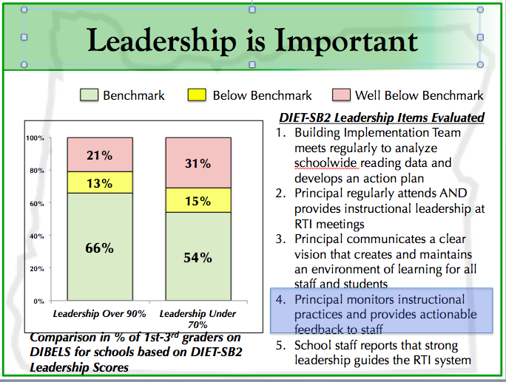

Schools with a Leadership score of over 90% consistently have higher student outcomes. Schools with a Leadership score of 70% or lower have lower student outcomes. Notice question number 4 is directly tied to walkthroughs. All of the leadership questions tie back to healthy, growth mindset and involved leader with a strong vision. Checking in on systems, providing feedback and support to improve implementation are critical
components of the leadership score.
Evidence suggests a Healthy School Culture is a correlated with improved student outcomes. Review the data below.

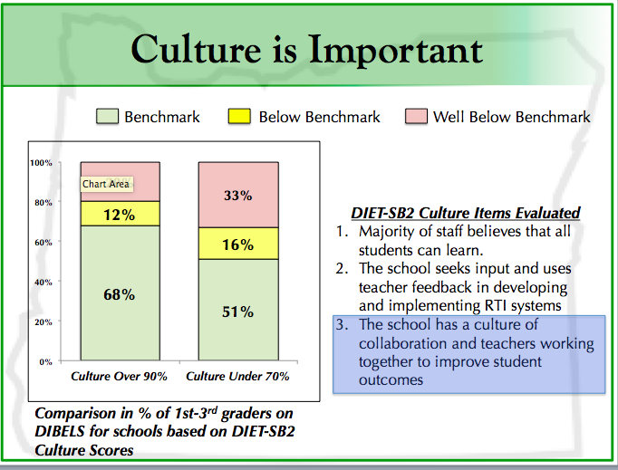

Schools with a 90% or higher score culture have improved student achievement data as compared to schools with a lower score on school culture. Creating a system fro teacher collaboration and support is a critical component of the healthy school culture. Core Review walkthroughs are a piece that school culture that has a growth mindset, seeks input and provides feedback.

Support for Walkthroughs and Teacher Collaboration

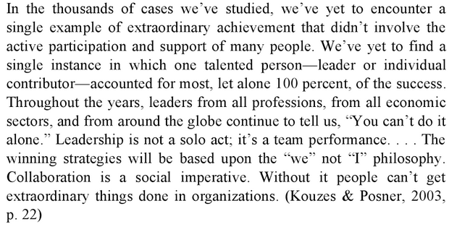
Leaders of Learning: How District, School, and Classroom Leaders Improve Student Achievement, By Richard DuFour, Robert J. Marzano
We often ask questions about how students learn, but not often about how teachers learn.
        - Professional Development Report 2013

The goal of Core Review walkthroughs is to support adult learning with ongoing and embedded professional learning based on identified areas of need. The goal is to support a school culture focused on learning for all where the adults in the system are the lead learners.

Creating a collegial culture within a school requires mutual respect, essential
conversations about teaching and learning, shared values and vision, time to share, clear expectations, teamwork, professional development, inquiry, and reflective practice. Barth 2006

The principal’s active support of the process should be evidenced by vocal support, by resources the principal makes available to the process:
- Time for walkthroughs
- Peer observations
- Providing video examples
- Encouraging reflection
- Following up with ongoing and embedded professional learning matched to discovered areas needs
and, most importantly, by active participation on the team as lead learner in the process. With a collective understanding of mutually agreed upon goals and a well articulated process for monitoring agreements around instruction in a collegial manner, we can learn together and continuously improve teacher instructional capacity and improve student learning.

Studies have shown that high performing schools have high levels of collaboration. “The nature of relationships among adults within a school has a greater influence on the character and quality of that school and on student accomplishment than anything else.” ~ Barth, 2006

- The most successful schools are schools where all the stakeholders work together to function as professional learning communities.
- Successful schools have strong and functional cultures that develop deliberately; they are nurtured and built by the school leadership, the principal, and the members of the learning community.

